**Final project Steps**

1. Registered for the AWS account and successfully created it. Created 3 instances – Server1(Jenkins-Server), Server2(Jenkins- Agent ) and Server3. Created key pair“Server1.pem” and used it for all three server to connect via CLI. Created security group to allow traffic for all ipv4 and ipv6, Anywhere.

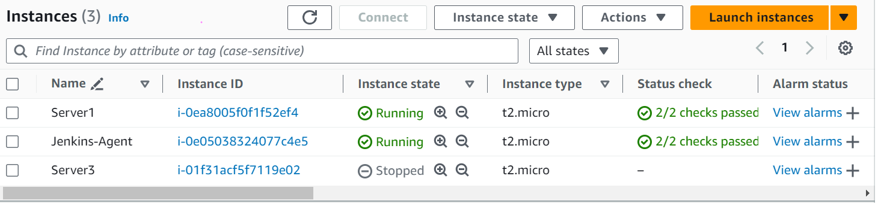

1. After starting the instance ran the command: # sudo apt-get update -y to update its libraries.
2. Installed java jdk 11 using the below command:

# sudo apt-get install openjdk-11-jdk -y

1. Checked java version: # java -version



1. Installed maven using below command:

# sudo apt install maven -y

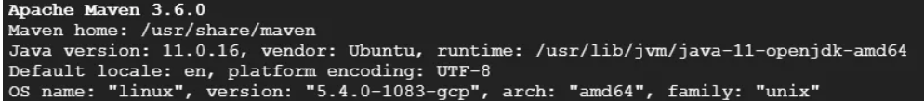

1. Installed Git and checked its version:

# sudo apt install git

# which git

1. Installed Jenkins using below commands from the Jenkins Website- <https://www.jenkins.io/doc/book/installing/linux/#debianubuntu>

sudo wget -O /usr/share/keyrings/jenkins-keyring.asc \

https://pkg.jenkins.io/debian-stable/jenkins.io-2023.key

echo "deb [signed-by=/usr/share/keyrings/jenkins-keyring.asc]" \

https://pkg.jenkins.io/debian-stable binary/ | sudo tee \

/etc/apt/sources.list.d/jenkins.list > /dev/null

sudo apt-get update

sudo apt-get install jenkins

1. Run the command: # sudo apt update
2. Created Firewall rule and specified the following details and click on Create button.Name: jenkins-port  
   Direction of traffic: Ingress  
   Action on match: Allow  
   Targets: All instances in this network  
   Source IPv4 ranges: 0.0.0.0/0  
   Check on the TCP checbox and specify Ports: 8080
3. Accessed Jenkins using the external IP(i.e. public i.p ) address of instance(Server1): public-ip:8080
4. Run the below command to fetch initial admin password for Jenkins setup:

# sudo cat /var/lib/jenkins/secrets/initialAdminPassword

1. Selected option to selected suggested plugins as shown in the image below:

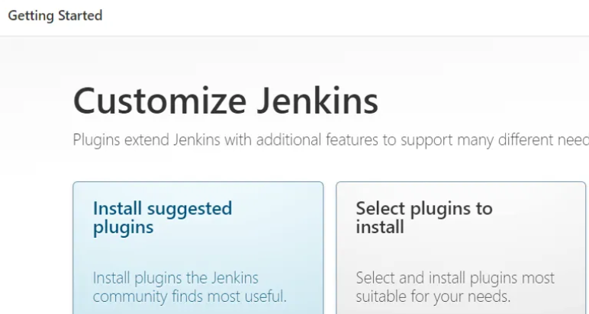

1. Post plugin installation, created an admin user for Jenkins, enter the following details: username, password, full name, email and clicked on the “Save and Continue” button.
2. On the next page, Instance configuration clicked on “Save and Finish” button, then clicked on Start using Jenkins button. Then got navigated to the Jenkins dashboard.

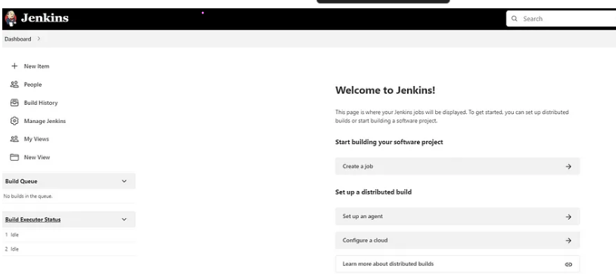

1. Created a freestyle job with the name clone repo and added git repo path and saved its credentials

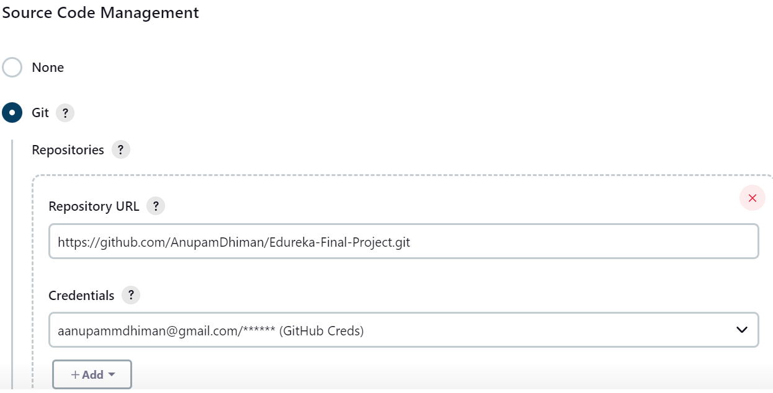

1. Under branch option set name as */main. As git repo is under main branch with public view settings. Also set Poll SCM to poll every minute so that updates are fetched every minute. Then saved the job and tested build is running successfully.

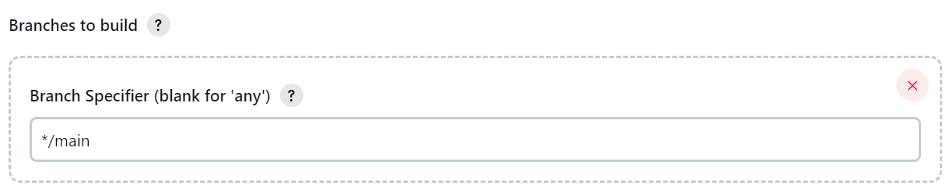

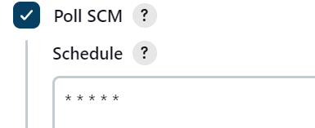

1. Under Manage Jenkins option on Dashboard > Tools added Maven version to use be used in jobs.

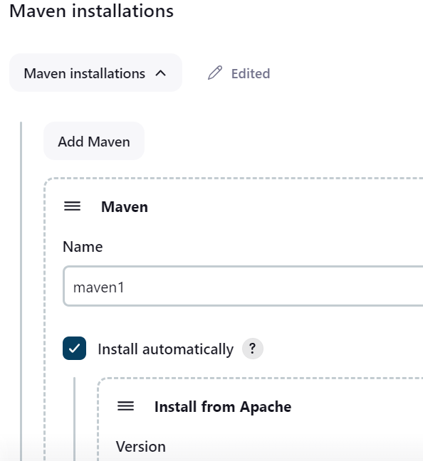

Installed plugins: Warning next generation, build pipeline, surefire, Junit and jacoco, Sonarqube etc.

1. Created a freestyle job: **Compile** and run the build successfully:

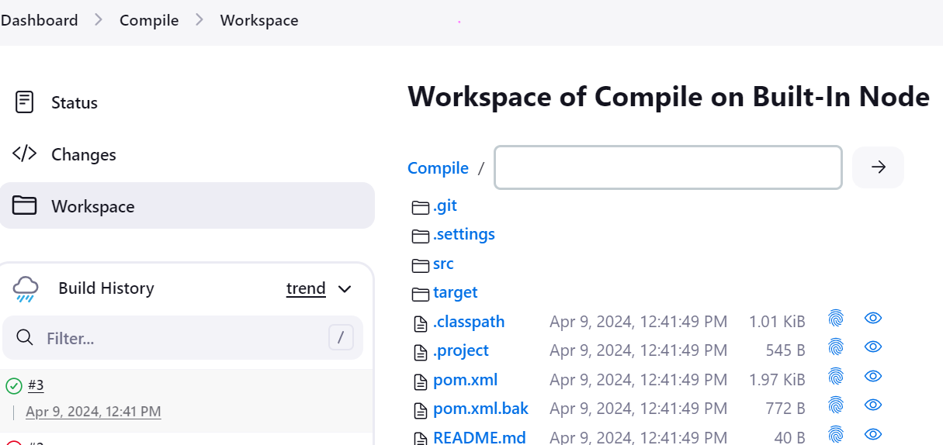

1. Created a freestyle job: **Test**. Entered Git repo url and saved git credentials. Under branch to build > Branch specifier: */main

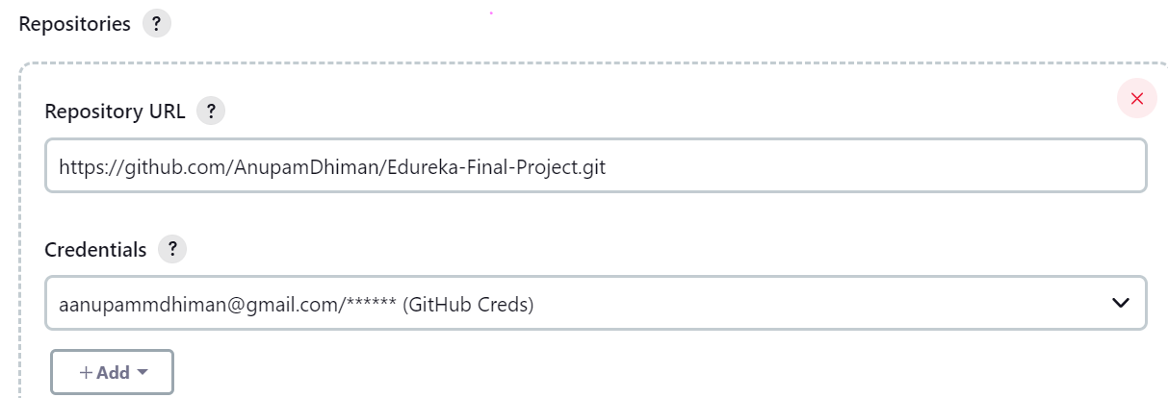

Added maven build steps:

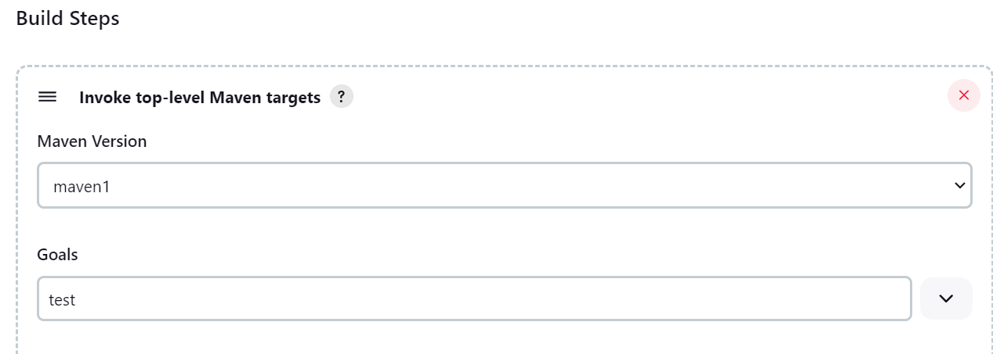

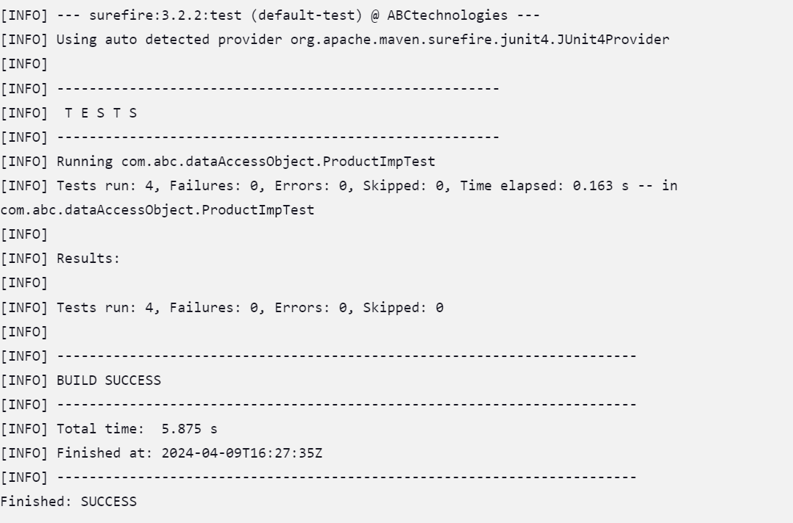

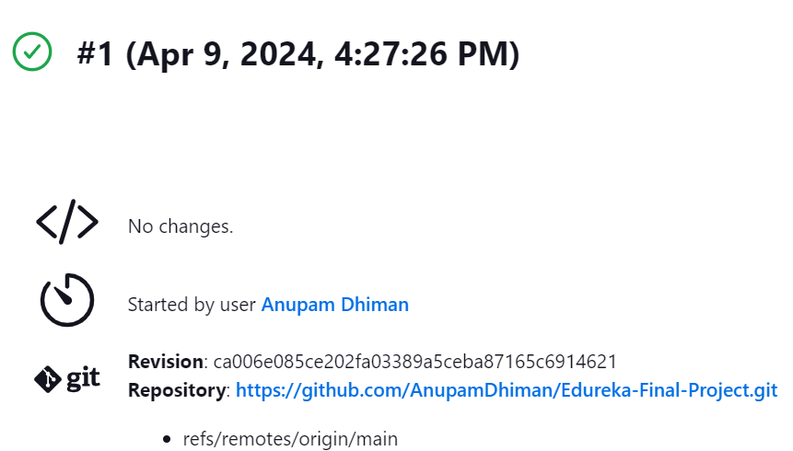

1. Created a freestyle job: **Package** and Entered Git repo url and saved git credentials. Under branch to build > Branch specifier: */main. Run the build successfully:



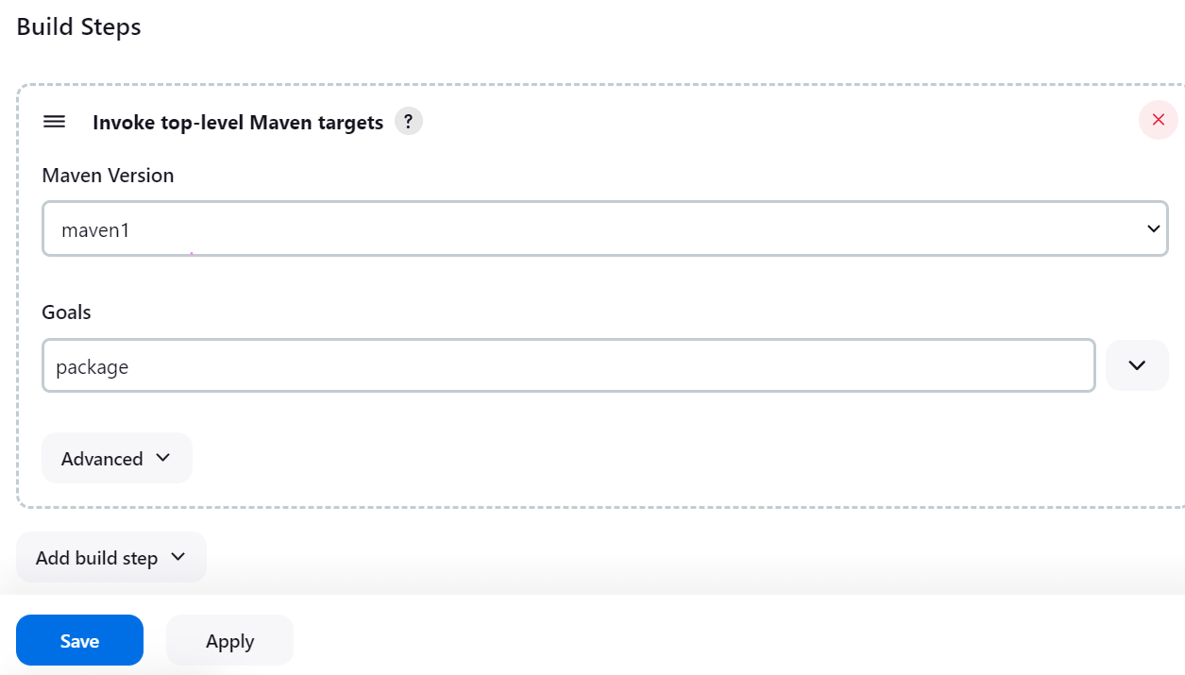

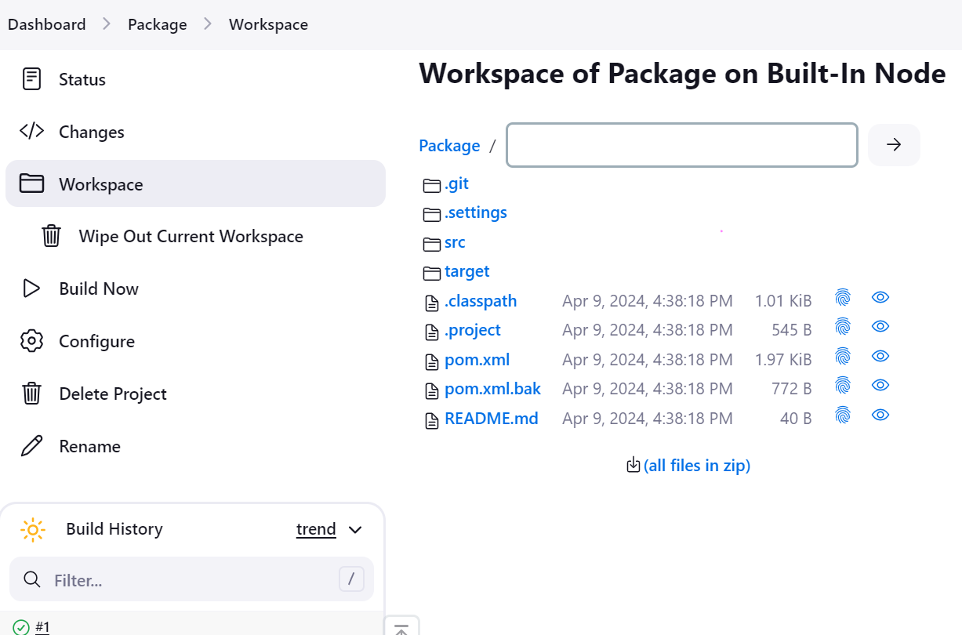

1. Created Pipeline and used snippet generator to fix an errors in the pipeline script. Pipeline script used is as below:

pipeline{

tools{

// what tool version to use for build stages

maven 'maven1'

}

//triggers {

// cron(* * * * *)

//pollscm('* * * * *')

//}

agent any

stages{

stage ('CloneRepo')

{

steps{

echo 'This is stage 1'

git branch: 'main', credentialsId: '111f8b8e-d708-4dc6-bc34-3371e0c4c315', url: 'https://github.com/AnupamDhiman/Edureka-Final-Project.git'

}

}

stage ('Compile')

{

steps{

sh 'mvn compile'

}

}

stage ('Test')

{

steps{

sh 'mvn test'

}

post{

success{

junit 'target/surefire-reports/*.xml'

}

}

}

stage('package')

{

steps{

sh 'mvn package'

}

}

}

}

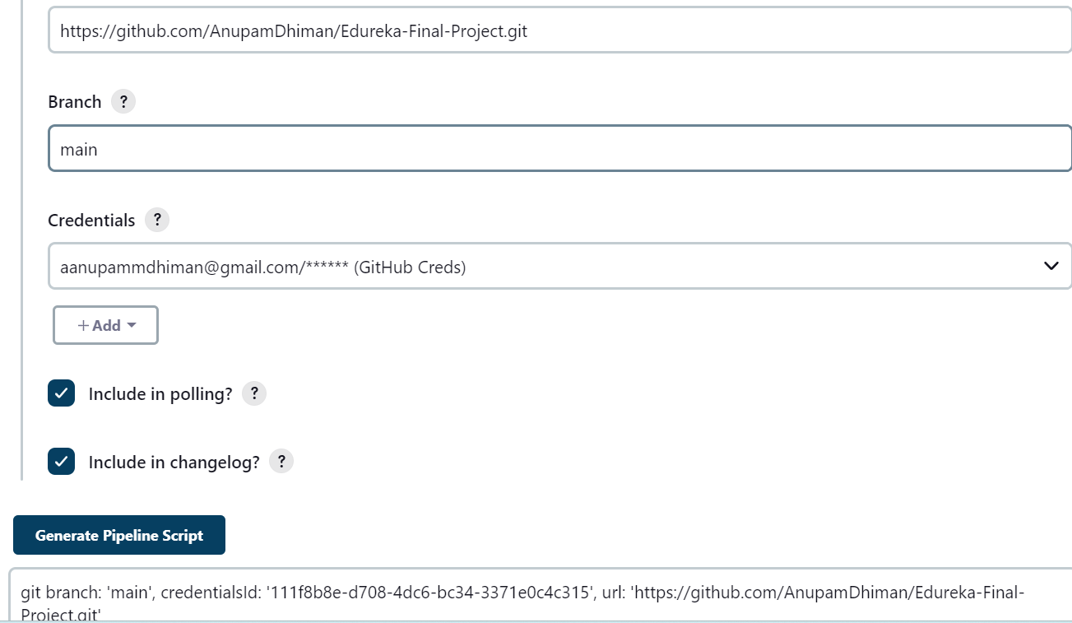

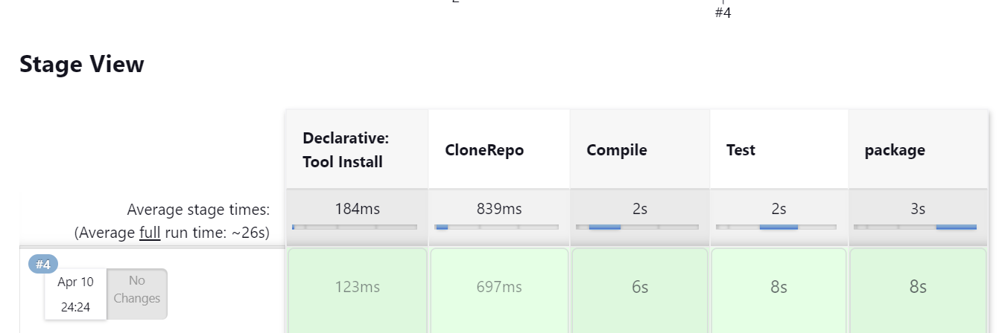

Pipeline Workspace details after successful execution as below:

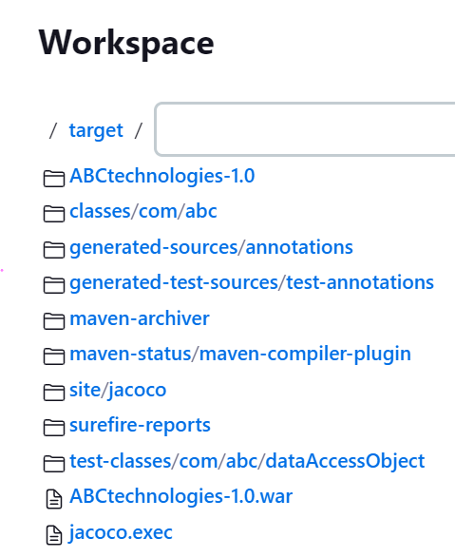

1. Jenkins Dashboard after successful Jobs and Pipeline(Compile+Test+Package) execution.

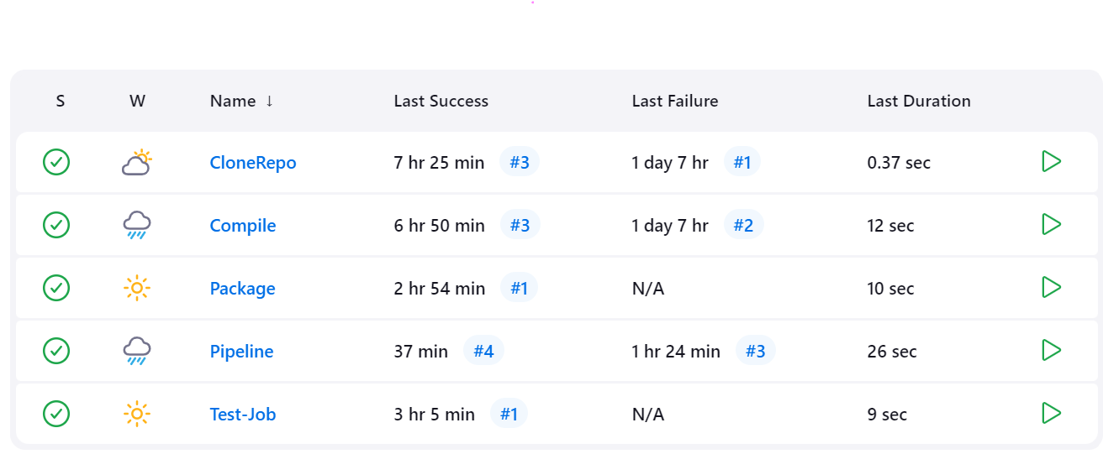

1. Added Node: Slave1 to the Jenkins:-

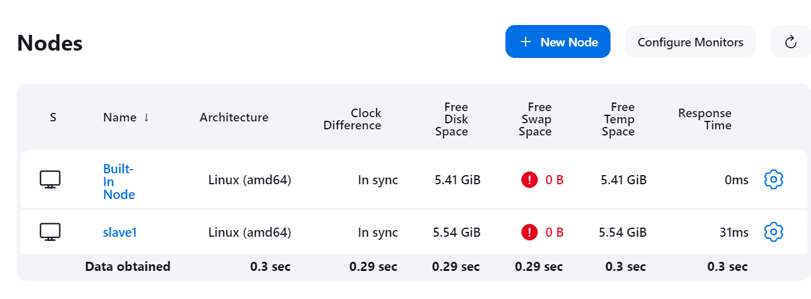24. Run the Jenkins package job successfully on the agent node- Slave1

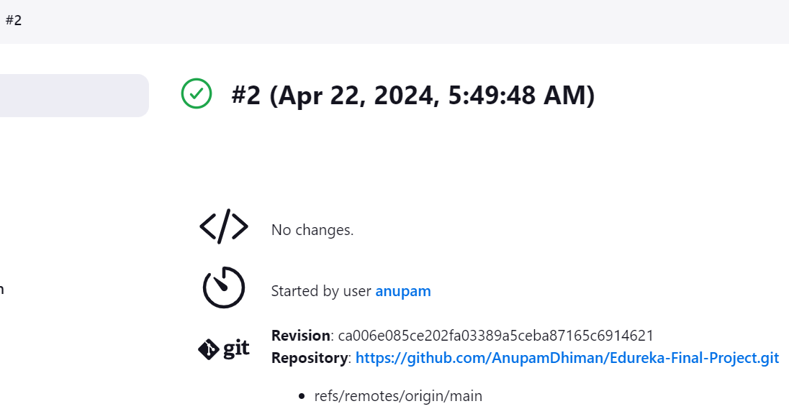

1. Run the pipeline on the Jenkins agent node: Slave1.

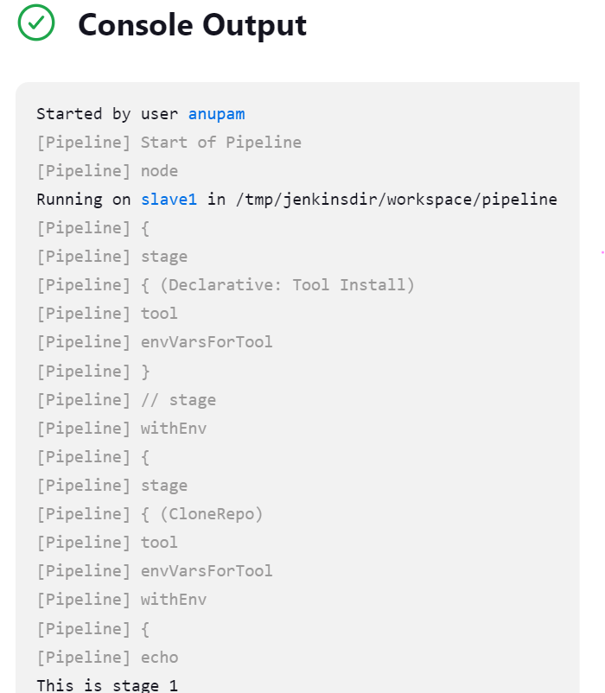

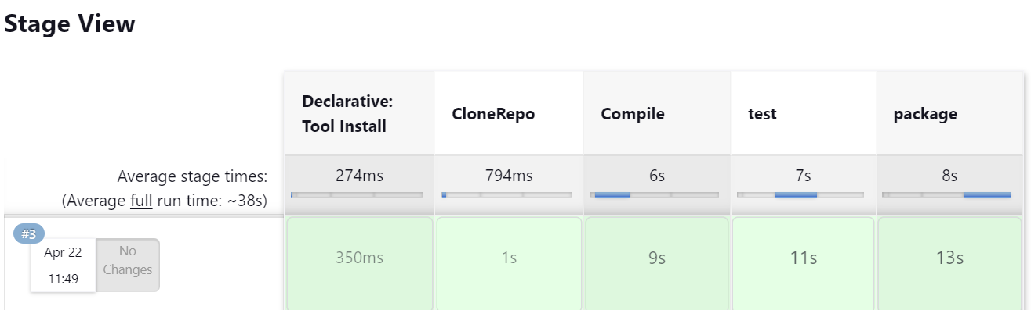

1. Modified the package job and added post build step, gave path of war file as **/*.war:

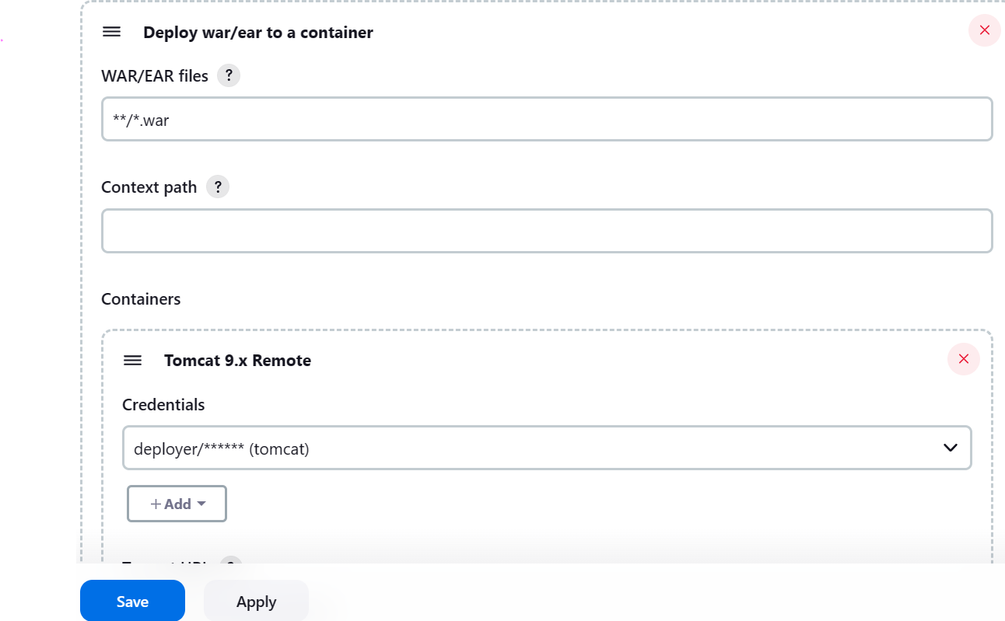

Added WAR/EAR files : **/*.war

For Containers:

click on add container--> select Tomcat 9.x Remote

Add credentials. Click on ADD button→ jenkins→

Username: deployer , password = deployer

Id = tomcat, description = tomcat. Added tomcat URL as well.

1. Save and Run the job and execute it.

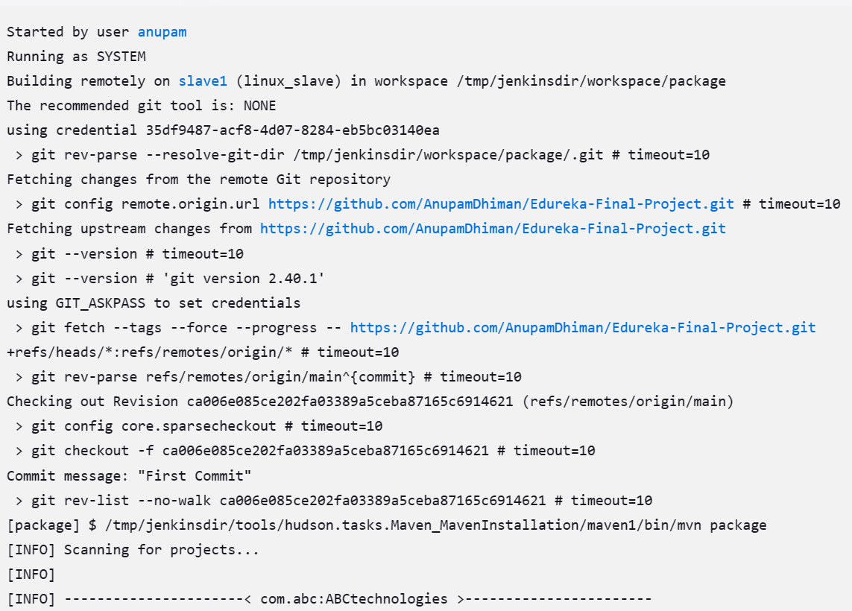

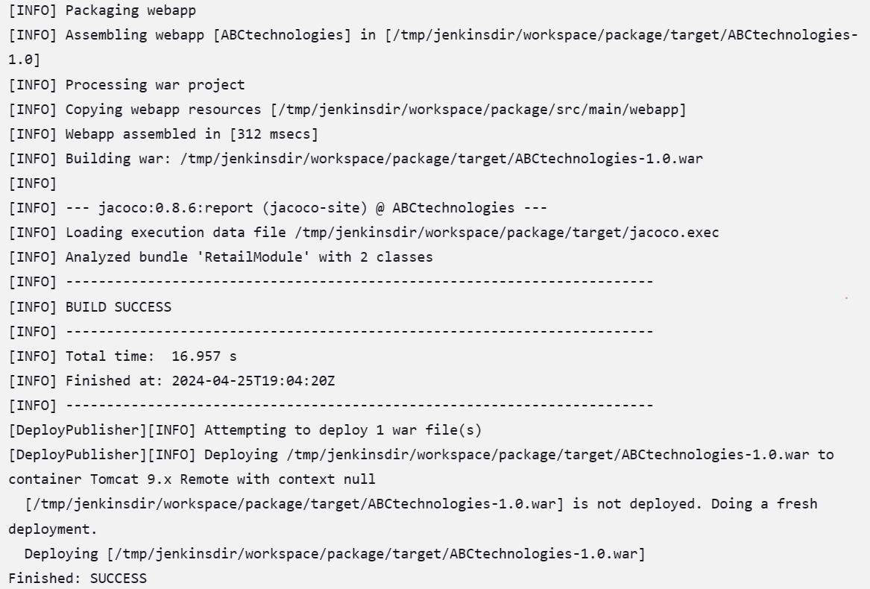

1. Verified application is running on tomcat

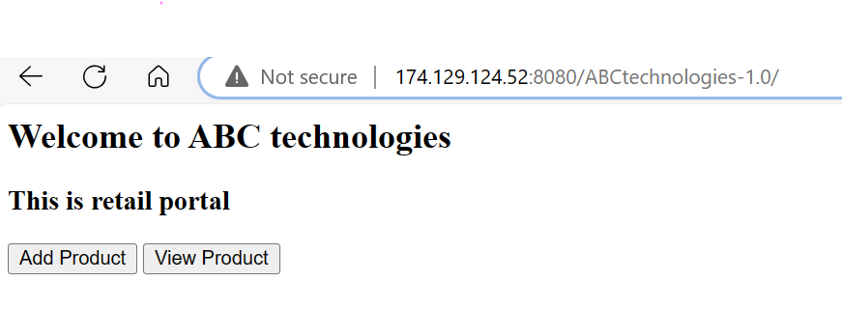

1. **Installed 2 new instances:** Tomcat and Ansible. Installed Docker on both the instances and Kubernetes on Tomcat. Ansible as Kubernetes worker node. Installed ansible on Ansible server.

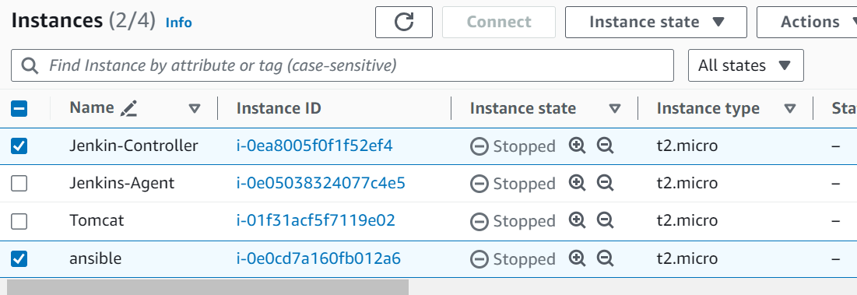

**Task 3 steps,**

**Step1:** Deploying .war file generated from package job into the tomcat server

**Issue 1:** And as part of Tomcat deployment I have tried to deploy using shell commands by copying the .war file to the webapps/ folder but it did not work and I got the below error at that time. Error message: "sudo: no tty present and no askpass program specified Build step 'Execute shell' marked build as failure Finished: FAILURE" I thought to copy the SSH public file to the slave machine but it not worked out. So finally, I followed a new way to deploy the .war file.

**Solution:** Added the 'Deploy to container' plugin and modified the package_docker_v2 job and configured the post-build action to deploy to the tomcat server.

**Issue 2:** After running the job I got an issue and was not able to get into the tomcat so i have configured the tomcat conf/tomcat-users.xml file with the below addition to the end like i have created a user as a tomcat and password as a admin for the role of manager-gui and manager_script and later it allowed me to deployed to the tomcat successfully.

**Solution:**

conf/tomcat-users.xml

<role rolename="manager-gui"/>

<role rolename="manager-script"/>

<user username="tomcat" password="admin" roles="manager-gui,manager-script"/

**Step 2:** Creating the docker build and docker container with above .war file generated from package command and uploading the docker image to the docker hub and running this docker image as container.

- As part of building docker images and uploading to dockerhub and running in the docker container. I tried to build the docker image manually in local and it got successful as part of that i have created a Dockerfile and added the plugins "cloudbees docker build and publish", “docker pipeline”, “docker plugin”,”docker build step”.

For telling jenkins to prepare docker image we need to build the DockerFile , now we need to give instructions to jenkins but it will read this Dockerfile in the home directory so i have placed this file in home directory and after build i have pushed the docker image to the docker hub for that i need to give my docker hub credentials to jenkins so for giving credentials i have configured the job in the build section "Docker build and publish" and validated in local and docker hub after build the job.

**Issue 4:** Got permission denied while trying to connect to the Docker daemon socket at unix:///var/run/docker.sock: Get http://%2Fvar%2Frun%2Fdocker.sock/v1.40/containers/json: dial unix /var/run/docker.sock: connect: permission denied

**Solution:** I have added the below commands in newly created build section Exceute shell before starting to build the docker image sudo chmod 666 /var/run/docker.sock sudo chmod 777 /var/lib/jenkins/.docker/config.json Sudo chmod 777 .docker

* And, also added the below additions in /etc/sudoers file(sudo file)

jenkins ALL=(ALL) NOPASSWD: ALL

**Issue 5:** jenkins.model.InvalidBuildsDir: ${ITEM_ROOTDIR}/builds does not exist and probably cannot be created at jenkins.model.Jenkins.checkRawBuildsDir(Jenkins.java:3085) at jenkins.model.Jenkins.loadConfig(Jenkins.java:3009) Caused: java.io.IOException **Solution:** experienced this when the $JENKINS_HOME/jobs directory had incorrect permissions or ownership so provided the permissions for jenkins user for this jenkins home directory.

**Issue 6:** While building docker image with Dockerfile it is not recognizing the .war file path that i have mentioned in Dockerfile and got below error ((ADD /var/lib/jenkins/workspace/package_kubernetes2/target/ABCtechnologies-1.0.war /usr/local/tomcat/webapps ADD failed: file not found in build context or excluded by .dockerignore: stat var/lib/jenkins/workspace/package_kubernetes2/target/ABCtechnologies-1.0.war)) **Solution:** So i did modified the Dockerfile with the below changes **/*.war instead of target/*.war

Steps to configure the job for docker integration after installed above mentioned plugins Create build tab with maven package and then ‘docker build and publish’ plugin added and go to configure In build tab -> select ‘docker build and publish’ -> Repository name(anupamdhiman/abctechnologies) -> and add Registry credentials with ‘username and password’- and that’s it it will get success.

**Docker file:**

FROM docker.io/library/ubuntu:18.04

RUN apt-get -y update && apt-get -y upgrade

RUN apt-get -y install openjdk-8-jdk wget

RUN mkdir /usr/local/tomcat

ADD https://dlcdn.apache.org/tomcat/tomcat-9/v9.0.88/bin/apache-tomcat-9.0.88.tar.gz /tmp/apache-tomcat-9.0.88.tar.gz

RUN cd /tmp && tar xvfz apache-tomcat-9.0.88.tar.gz

RUN cp -Rv /tmp/apache-tomcat-9.0.88/* /usr/local/tomcat/

ADD **/*.war /usr/local/tomcat/webapps

EXPOSE 8081

EXPOSE 8080

CMD /usr/local/tomcat/bin/catalina.sh run

Changed tomcat port to 8081 in conf file. Ubuntu image and modifying the image with installation of java and tomcat and then deploying the .war file to the tomcat container and running this container.

1. Configuration of modified package job to Create an Image and container on the Docker host. Integrate docker host with Jenkins. Create CI/CD job on Jenkins to build and deploy on a container.

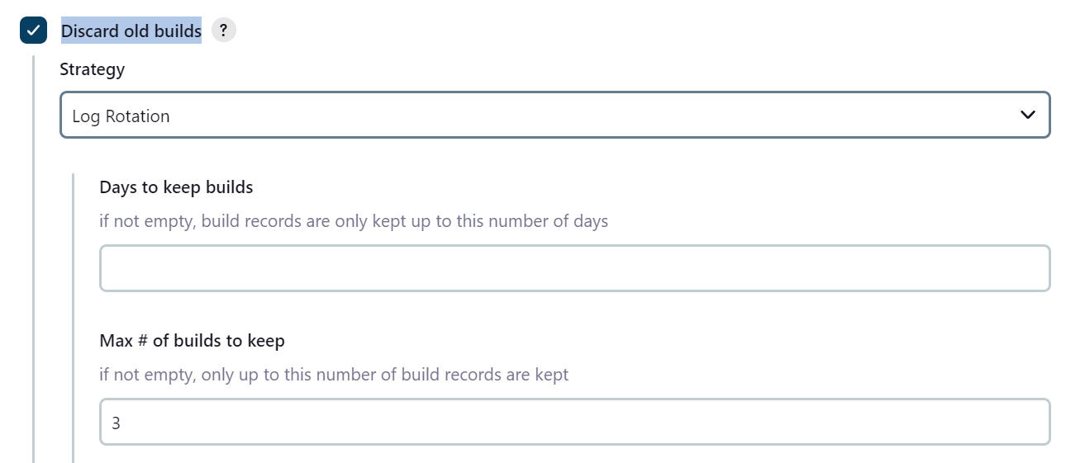

**Source code management configuration of job:**

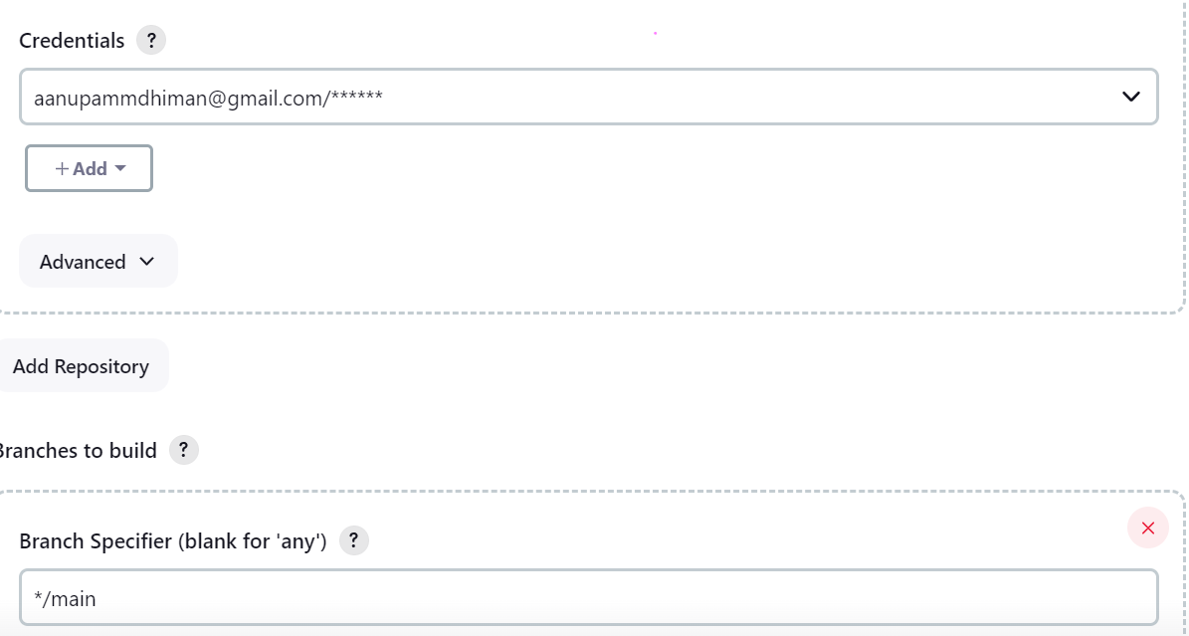

**Maven configuration as below:**

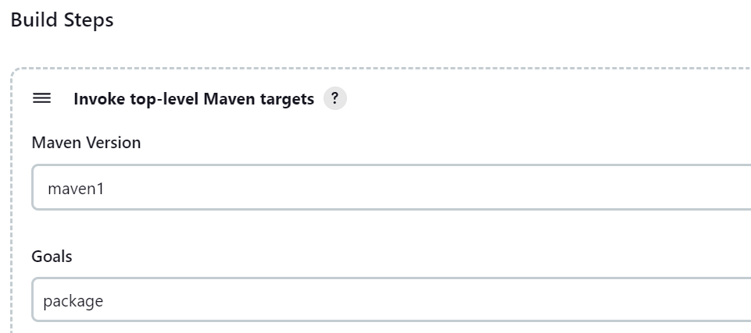

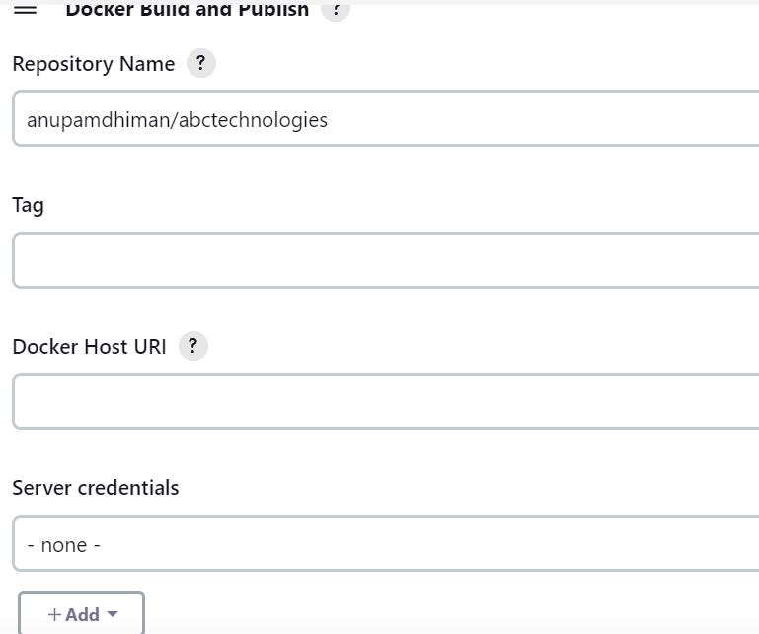

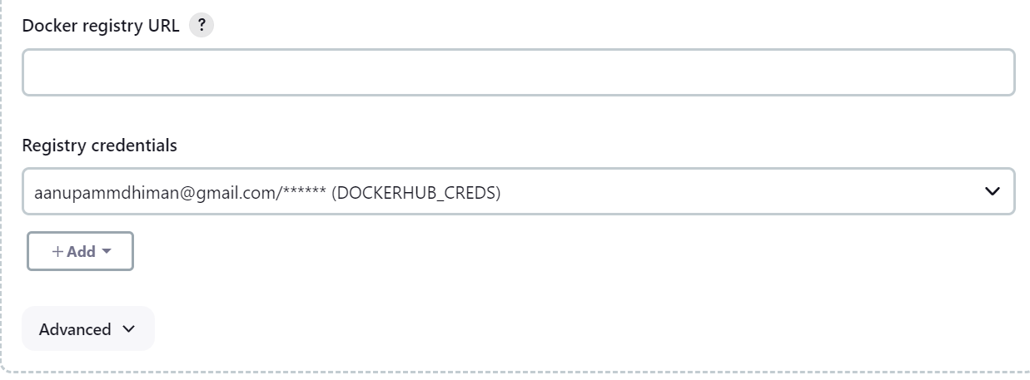

**DockerHub credentials saved in the Docker Build and Publish build job.**

1. Executed shell commands to run the docker

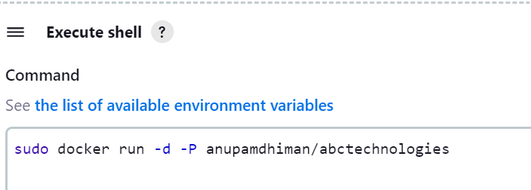

1. Post build actions for tomcat

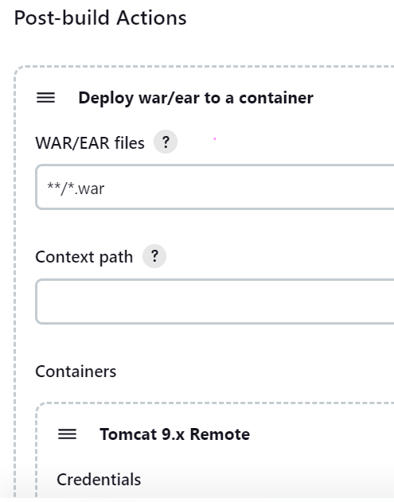

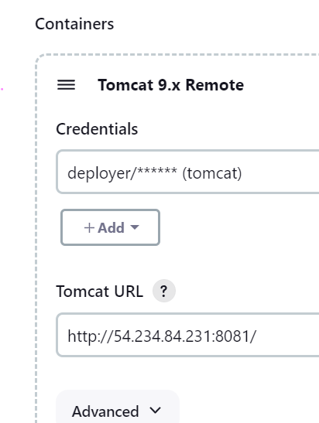

1. Successfully run the job, screenshots as below:   
   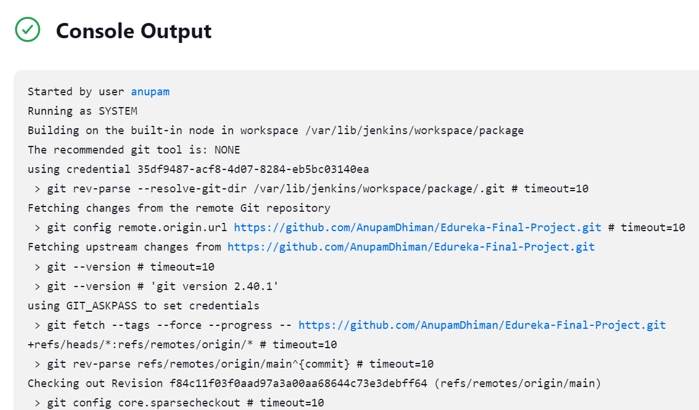

**Package Job Success:**

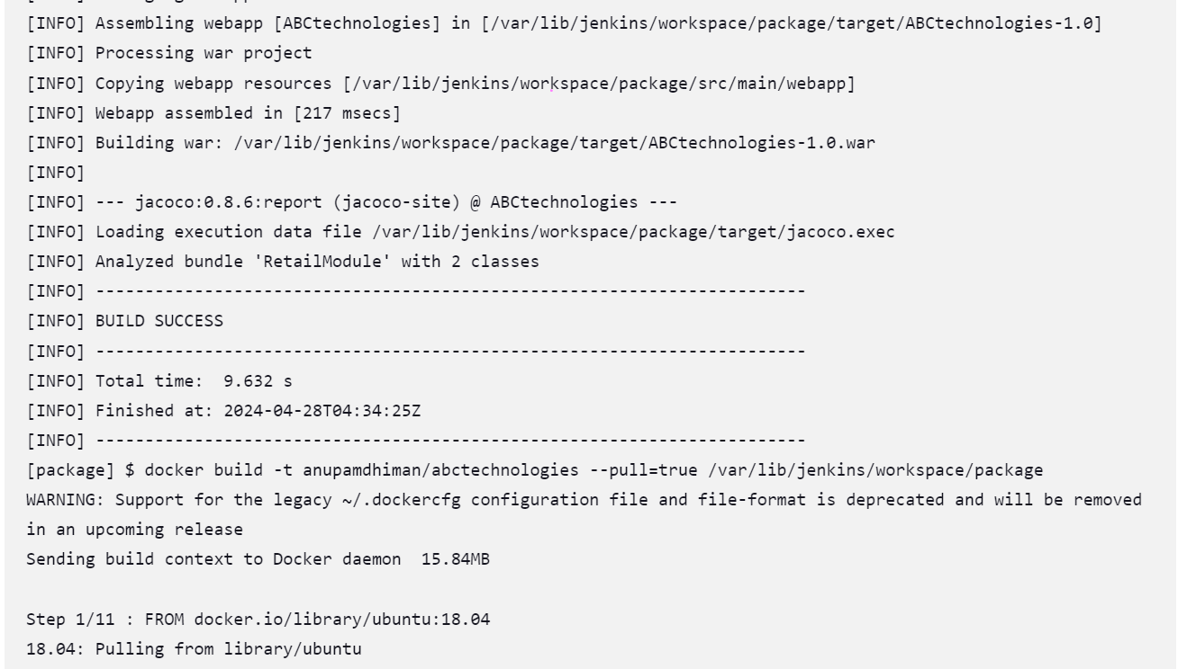

**DockerHub push success message:**

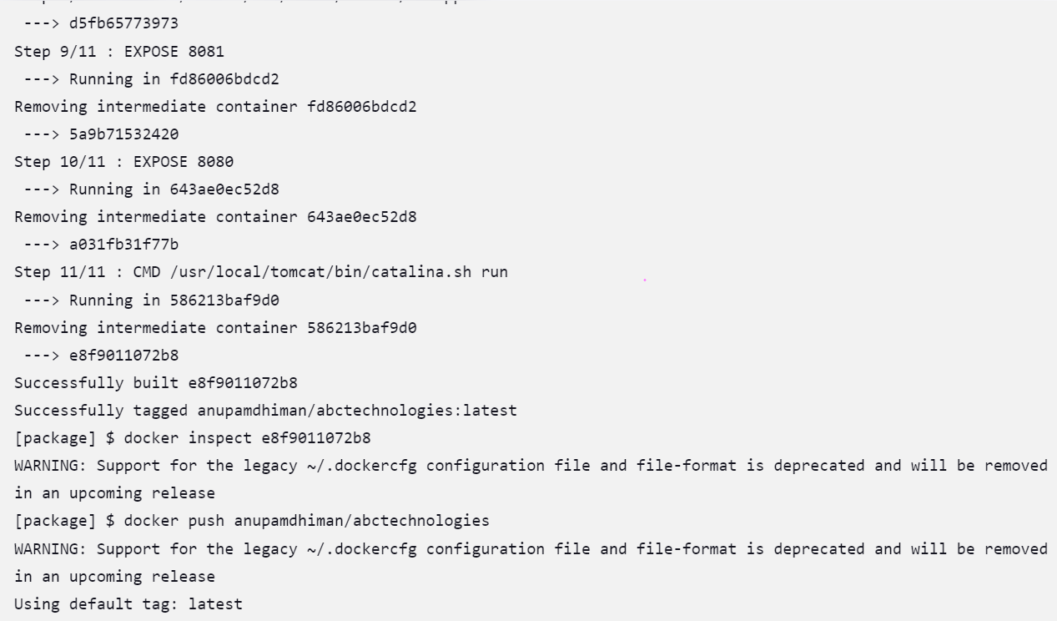

**Docker push and tomcat running success message.**

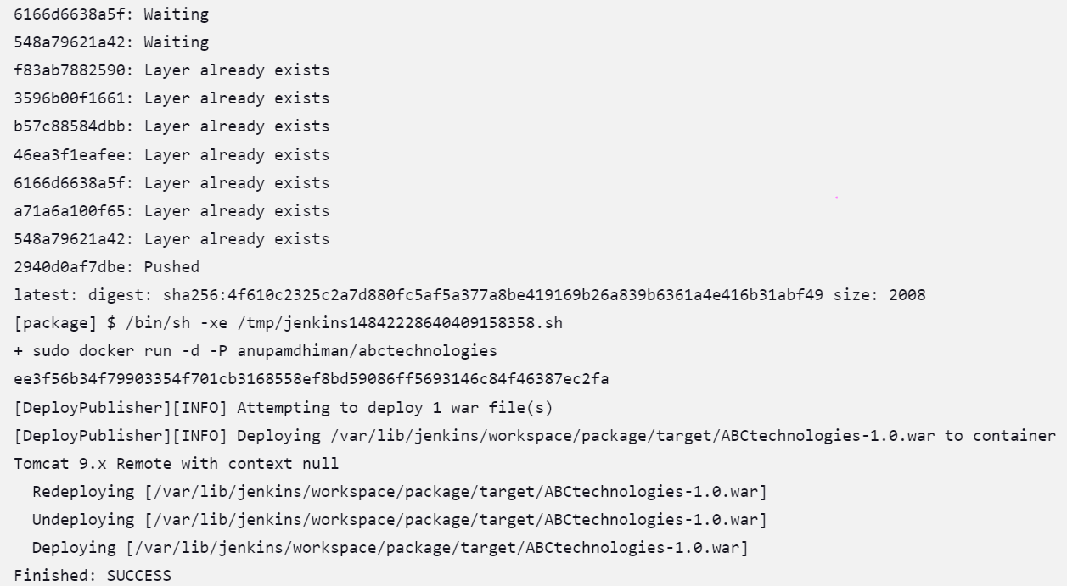

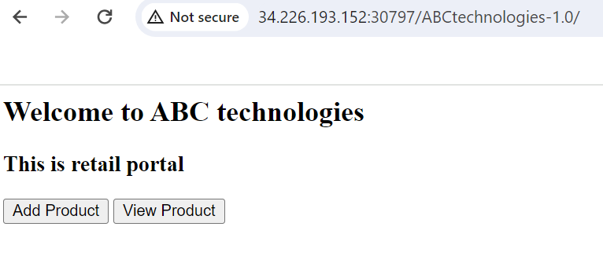

1. **Image pushed to DockerHub successfully:**

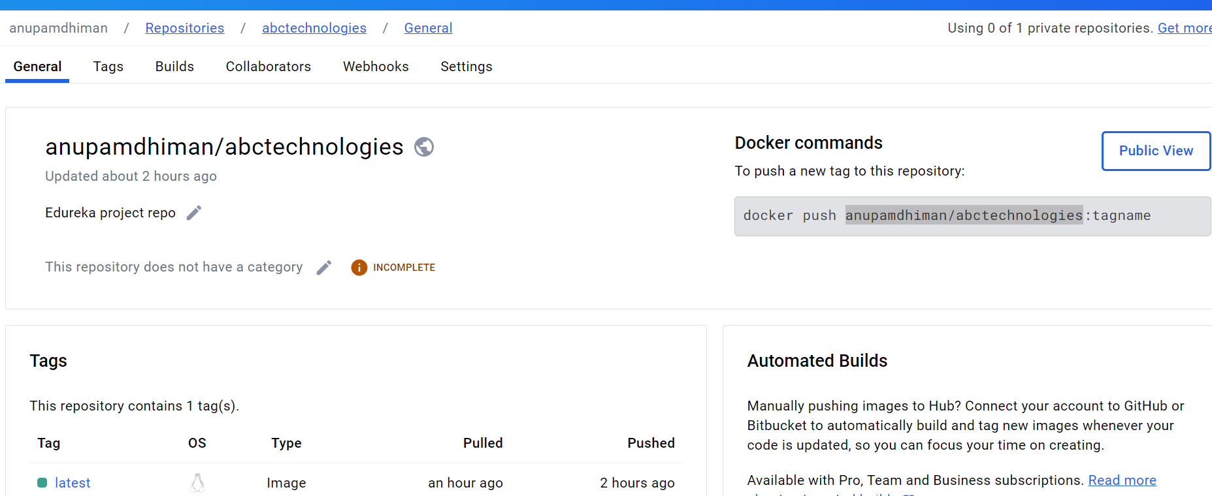

1. **Creating Pipeline:**

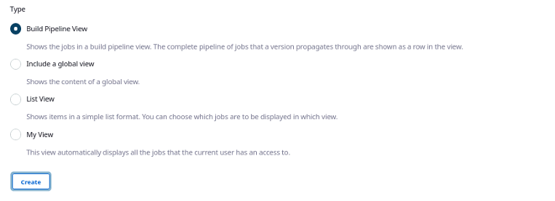

**Setting the Upstream:**

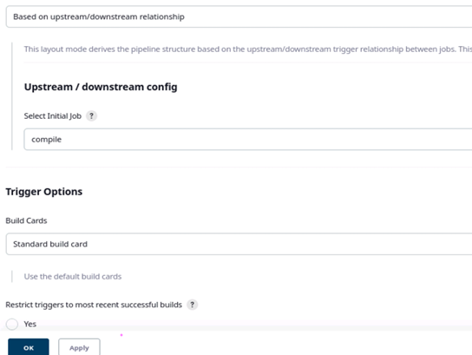

**Modifying the job configuration for pipeline connectivity:**

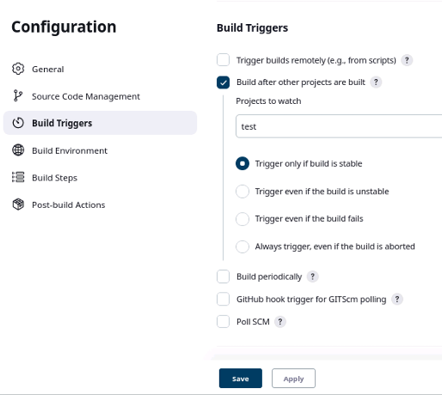

**Validating in build and showing Test job as a downstream for compile job:**

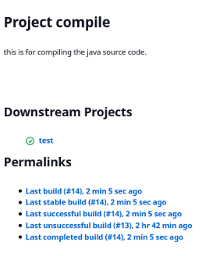

**Task 4:** Integrate the Docker host with Ansible. Write an Ansible playbook to create an image and create a continer. Integrate Ansible with Jenkins. Deploy Ansible-playbook. CI/CD job to build code on ansible and deploy it on docker container.

1. Deploy Artifacts on Kubernetes

2. Write pod, service, and deployment manifest file

3. Integrate Kubernetes with Ansible

4. Ansible playbook to create deployment and service.

- **The task-4 starting of integrating the jenkins with ansible. and creating the ansible playbook integration of docker and then kubernetes.**

- And this task is an extension of the last task so I have used the DockerFile I prepared in the last task and added a few more steps.

- First of all i have configured the ansible hosts file with localhost and copied the self public key to the master machine as jenkins needs authentication internally to connect to the localhost(self) otherwise i will get authentication errors.

ansible 2.9.23

config file = /etc/ansible/ansible.cfg

configured module search path = [u'/home/ec2-user/.ansible/plugins/modules', u'/usr/share/ansible/plugins/modules']

ansible python module location = /usr/lib/python2.7/site-packages/ansible

executable location = /usr/bin/ansible

python version = 2.7.18 (default, Dec 18 2023, 22:08:43) [GCC 7.3.1 20180712 (Red Hat 7.3.1-17)]

So i have installed the ansible plugin in jenkins to run the playbook with provided ansible-playbook and inventory file paths to run the ansible-playbook.

**Ansible playbook:- play1.yml**

**[ec2-user@Ansible ~]$ cat play1.yml**

**---**

**- hosts: all**

**become: yes**

**become_user: root**

**tasks:**

**- name: install docker**

**yum:**

**name: docker**

**state: present**

**notify:**

**- restart docker**

**- name: run docker container**

**command: sudo docker run -itd -P anupamdhiman/abctechnologies**

**- name: create deployment**

**command: kubectl --kubeconfig=/etc/kubernetes/admin.conf create -f /home/ec2-user/deploy.yml**

**- name: create service**

**command: kubectl --kubeconfig=/etc/kubernetes/admin.conf create -f /home/ec2-user/service.yml**

**handlers:**

**- name: restart docker**

**service:**

**name: docker**

**start: start**

**There are 3 tasks created above in an ansible file.**

1) Building the docker image and pushing to docker hub(- name: Build an image and push it to a private repo )

2) Run the build docker container ( - name: start a container )

3) deploying to Kubernetes.

**Deployment.yml file:**

**cat deploy.yml**

**apiVersion: apps/v1**

**kind: Deployment**

**metadata:**

**name: test1**

**labels:**

**app: test1**

**spec:**

**replicas: 2**

**selector:**

**matchLabels:**

**app: test1**

**template:**

**metadata:**

**labels:**

**app: test1**

**spec:**

**containers:**

**- name: cont1**

**image: anupamdhiman/abctechnologies**

**ports:**

**- containerPort: 8080**

**Service.yml file:**

**cat service.yml**

**apiVersion: v1**

**kind: Service**

**metadata:**

**name: svc1**

**spec:**

**type: NodePort**

**selector:**

**app: test1**

**ports:**

**- protocol: TCP**

**port: 8080**

**targetPort: 8080**

-While doing this task i have encounter some issues as below

**Issue1:** Permission error

**Solution:** And add this permission for jenkins user in /etc/sudoers file, jenkins ALL=(ALL) NOPASSWD: ALL

**Issue2:** Failed to connect to the host via ssh: Warning: Permanently added 'localhost' (ECDSA) to the list of known hosts. jenkins@localhost: Permission denied (publickey,password). **Solution:** So added the ssh key(public) to the self jenkins user as well then it works without giving the above error.

**Downloaded the ansible plugin:**

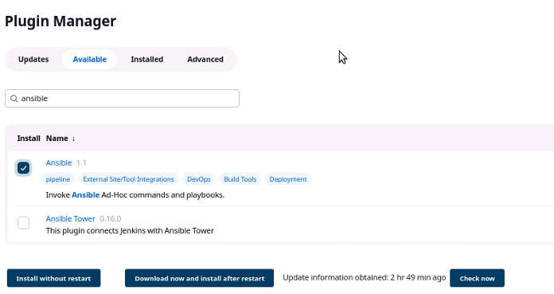

**Plugin installed successfully:**

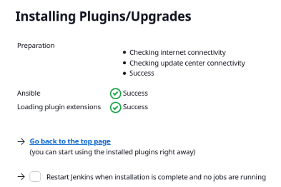

**Creating the job(package_kubernetes_v2):**

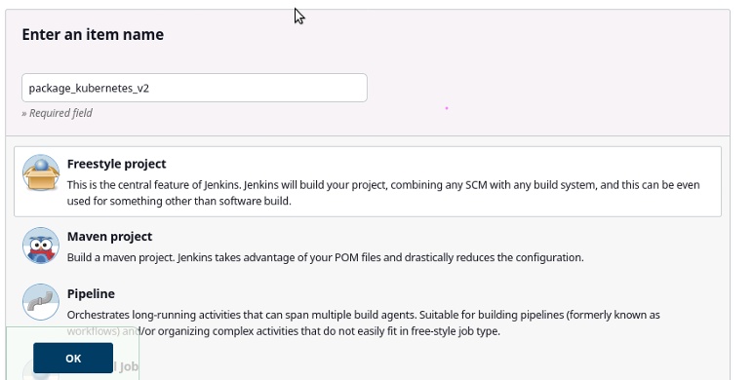

**Setting up the git repository:**



**Choosing ‘Invoke ansible playbook’ option in build site:**

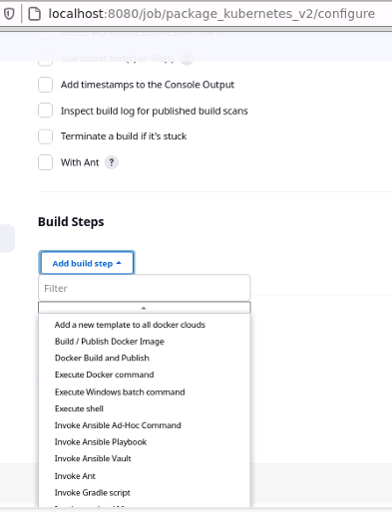

**Giving ansible-playbook path to run from jenkins**

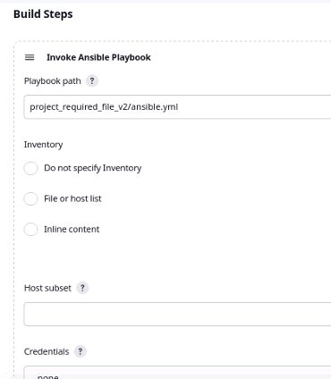

**After running the build after setting up it got success Git started getting updated code from Github:**

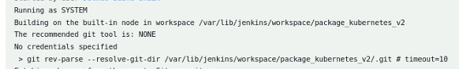

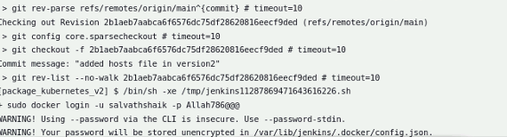

**Docker login and docker push has been started**

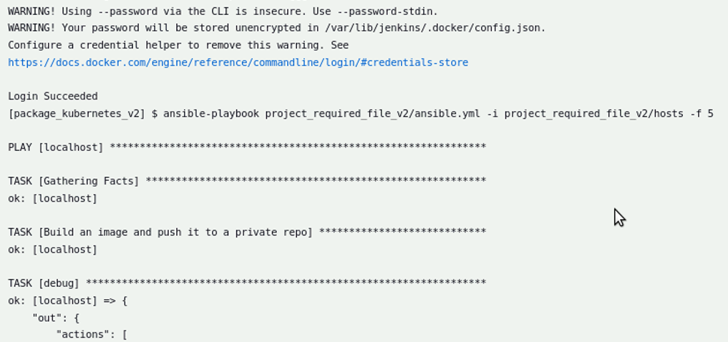

**Deploying to kubernetes has been started:**

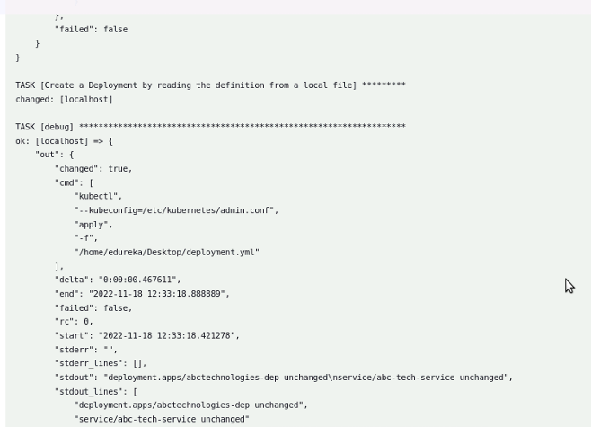

**Pacakge_kubernetes_v2 job got success message:**

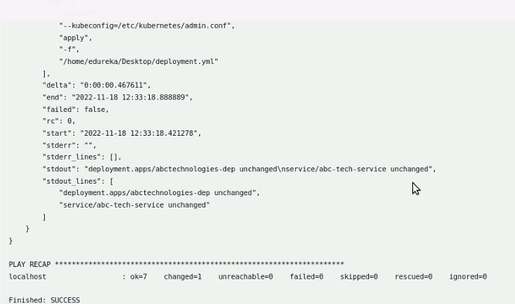

**Validating the kubernetes container with service port**

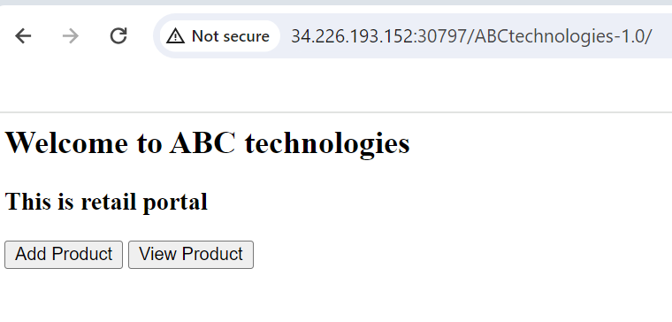

**References i have followed:**

https://docs.ansible.com/ansible/latest/collections/community/docker/docker_image_module. html https://docs.ansible.com/ansible/latest/collections/community/docker/docker_container_mod ule.html https://github.com/ansible-collections/community.docker https://pypi.org/project/docker/ https://pypi.org/project/docker-py/ https://github.com/ansible-collections/community.docker https://docker-py.readthedocs.io/en/latest/ https://www.baeldung.com/ops/docker-removing-images#:~:text=Forcefully%20Remove%20 Containers%20and%20Images&text=The%20%2Df%20flag%20is%20used,the%20running %20Docker%20containers%20forcefully.&text=The%20docker%20images%20%2Dqa%20wi ll,forcefully%20remove%20the%20Docker%20image https://stackoverflow.com/questions/22769568/system-specific-variables-in-ansible https://stackoverflow.com/questions/60834692/how-to-completely-remove-ansible-2-8-3-on-u buntu-18-04-- https://docs.ansible.com/ansible/2.6/modules/k8s_module.html#examples https://docs.ansible.com/ansible/latest/user_guide/guide_rolling_upgrade.html https://adamtheautomator.com/ansible-kubernetes/ https://adamtheautomator.com/ansible-template/ ansible-playbook sample-playbook.yml -e 'ansible_python_interpreter=/usr/bin/python3' https://docs.ansible.com/ansible/latest/reference_appendices/python_3_support.html https://docs.ansible.com/ansible/2.9/modules/k8s_service_module.html https://github.com/DeekshithSN/sample-web-application https://www.youtube.com/watch?v=NSk0NHkTjDs https://www.baeldung.com/ops/jenkins-parameterized-builds https://stackoverflow.com/questions/56003777/how-to-pass-environment-variable-in-kubectl deployment https://stackoverflow.com/questions/62108860/kubectl-no-matches-for-kind-service-in-versio n-apps-v1 https://stackoverflow.com/questions/59579482/kubectl-apply-error-from-server-forbidden-aut hentication-required-jenkin

**Task 5:** Using Prometheus, monitor the resources like CPU utilization: Total Usage, Usage per core, usage breakdown, memory, and network on the instance by providing the endpoints on the local host. Install the node exporter and add the URL to the target in Prometheus. Using this data, log in to Grafana and create a dashboard to show the metrics.

**Approach i have followed:** First of all we need to have prometheus,Grafana but edureka lab already installed these tools. So I had installed the node-exporter in master node to monitor the metrics of a node and added the target url in the prometheus.yml file so that prometheus will start to monitor.

And, I have monitored and captured the CPU,memory and network of the target node. And I have created a dashboard by selecting the prometheus app from Grafana and then created a Panel for visualizing the metrics in Grafana.

After installing node_exporter I have added the below job in the prometheus.yml file to get the metrics from the target.

—----------

job_name: 'node_exporter'

scrape_interval: 5s

static_configs:- targets: ['localhost:9100']

—--------

/opt/prometheus-2.27/prometheus.yml

# my global config

global:

scrape_interval: 15s # Set the scrape interval to every 15 seconds. Default is

every 1 minute.

evaluation_interval: 15s # Evaluate rules every 15 seconds. The default is every 1

minute.

# scrape_timeout is set to the global default (10s).

# Alertmanager configuration

alerting:

alertmanagers:- static_configs:- targets:

# - alertmanager:9093

# Load rules once and periodically evaluate them according to the global

'evaluation_interval'.

rule_files:

# - "first_rules.yml"

# - "second_rules.yml"

# A scrape configuration containing exactly one endpoint to scrape:

# Here it's Prometheus itself.

scrape_configs:

# The job name is added as a label `job=<job_name>` to any timeseries scraped

from this config.- job_name: 'prometheus'

# metrics_path defaults to '/metrics'

# scheme defaults to 'http'.

static_configs:- targets: ['localhost:9090']- job_name: 'node_exporter'

scrape_interval: 5s

static_configs:- targets: ['localhost:9100']

Please find the screenshots:

**Prometheus self monitoring:**

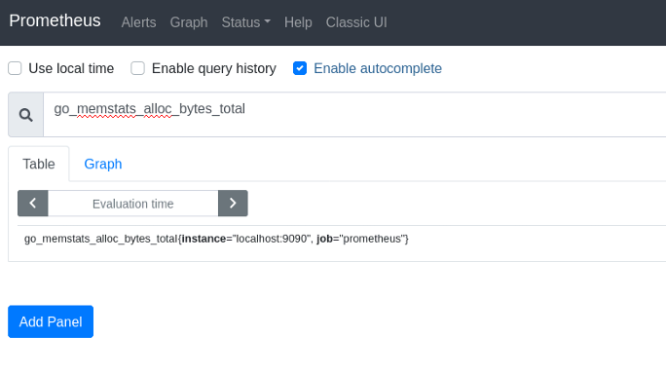

**Graph visualization for the metrics in prometheus:**

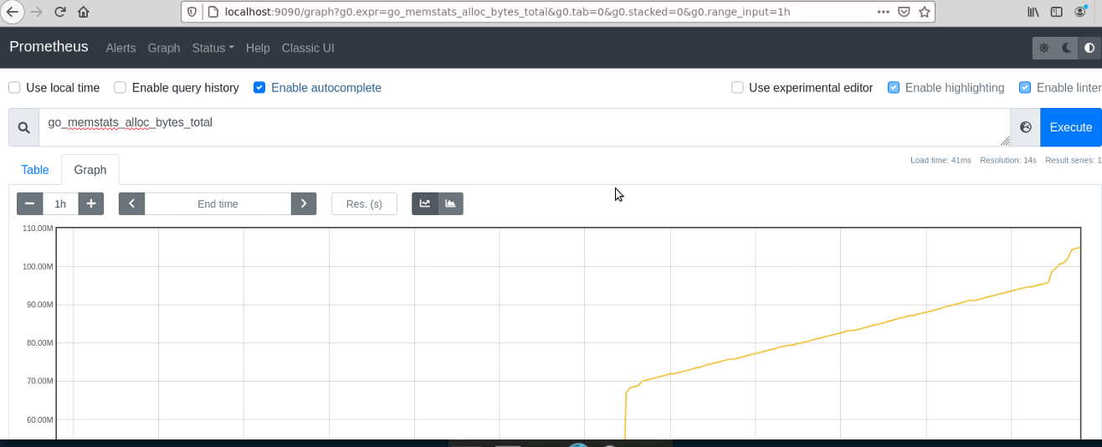

**Prometheus application self target before adding our required target:**

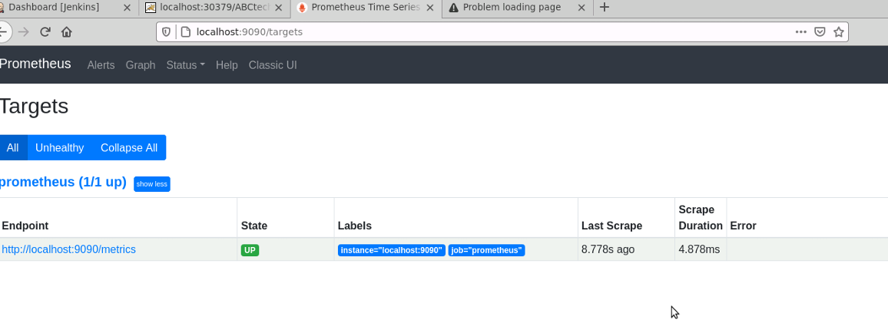

**Alerts tab: If we configured alert manager it will list the alerts here:**

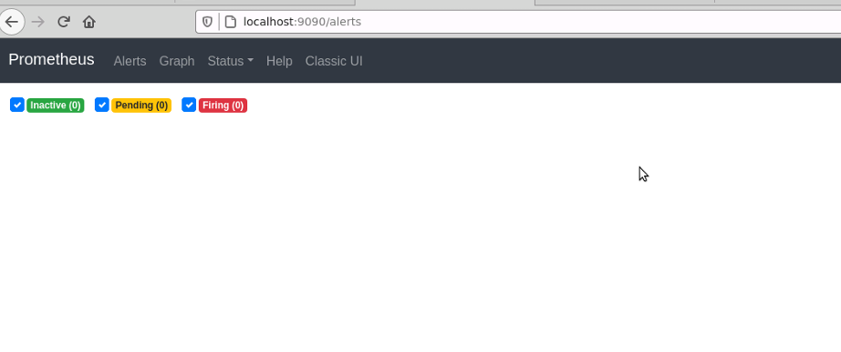

**Node exporter data validation through target:**

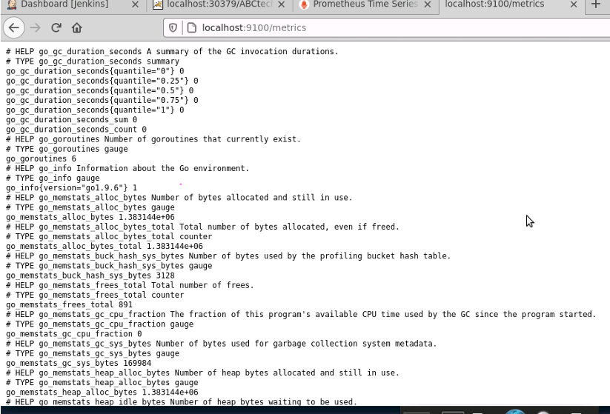

**Added_target in prometheus file**

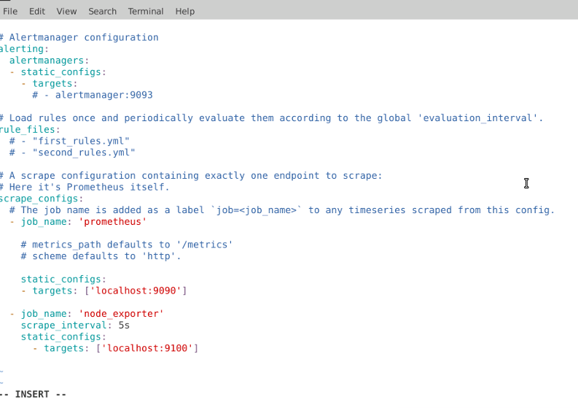

**Prometheus_targets page with node exporter of a node:**

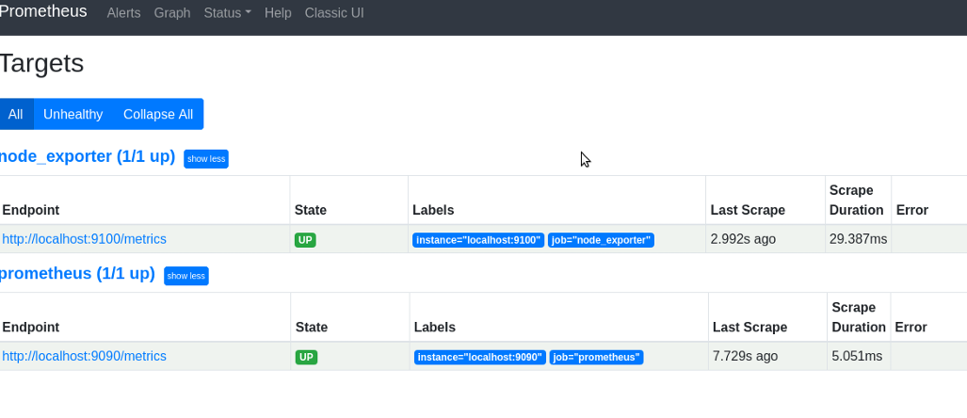

**cpu usage breakdown for node**

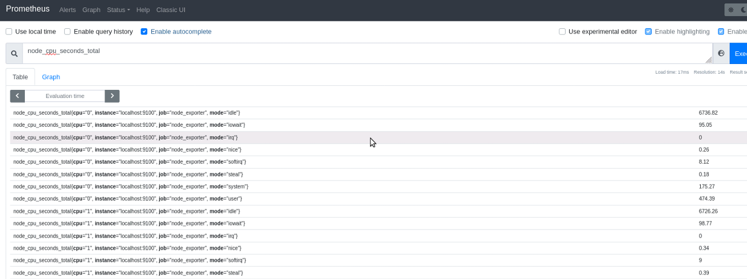

**Total count of cpu usage in seconds:**

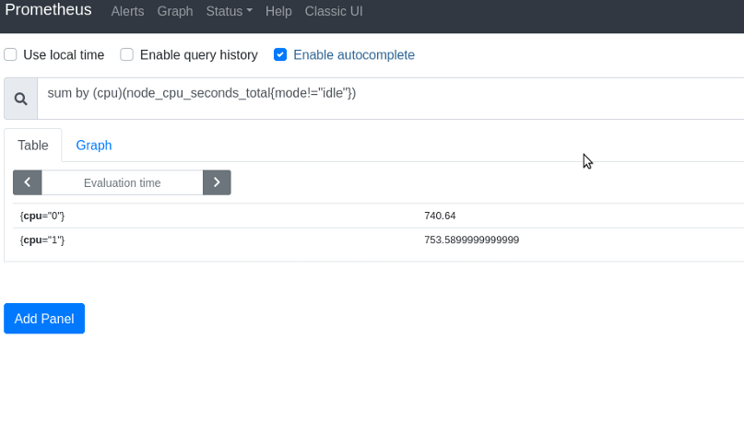

**Total count of cpu in seconds from starting**

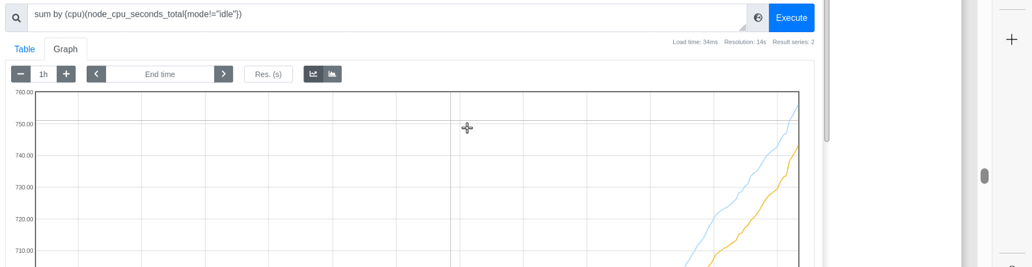

**Rate of growth for cpu in last 5 minutes**

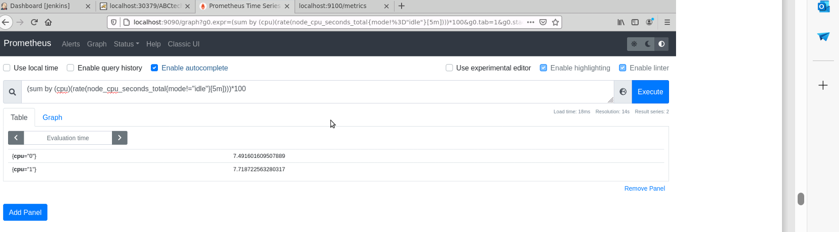

**Rate of growth for cpu in 5 minutes graph:**

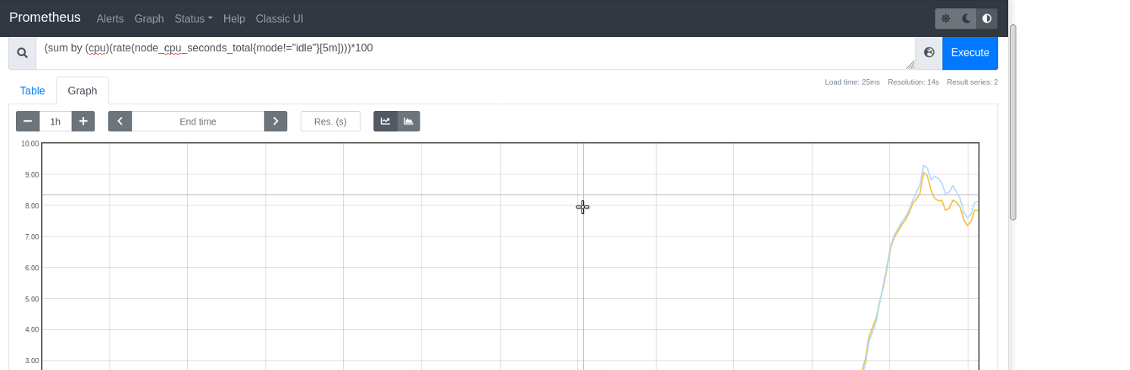

**CPU Utilization**

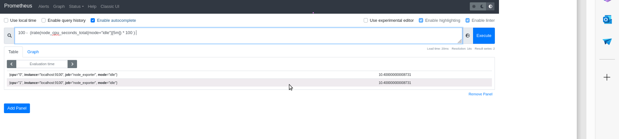

**CPU Utilization graph**

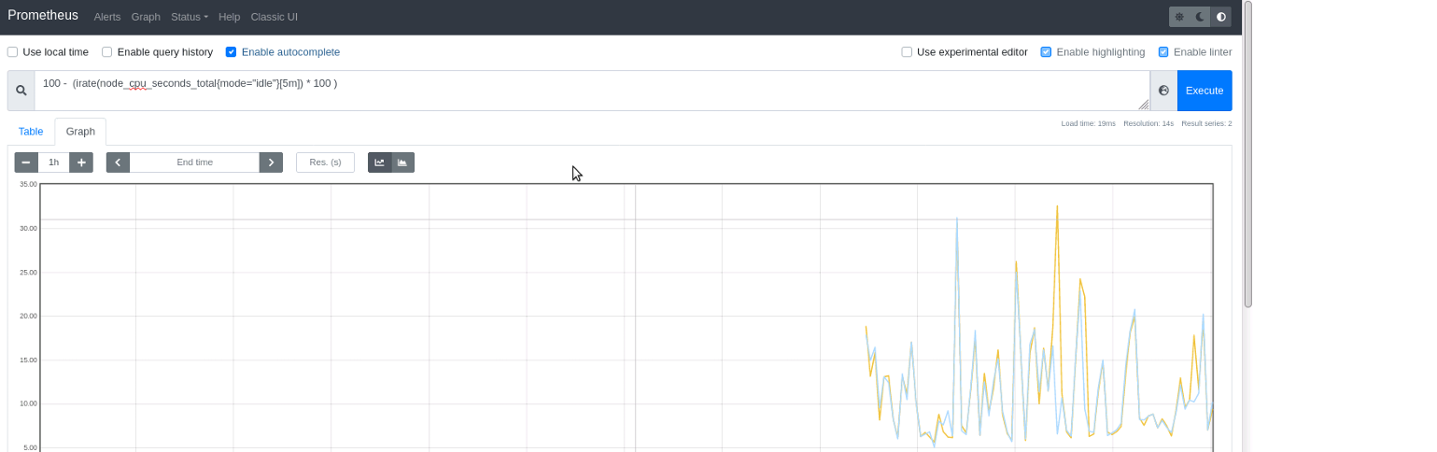

Some of the commands i have used for CPU monitoring:



**Memory monitoring**

**Node memory available in bytes:**

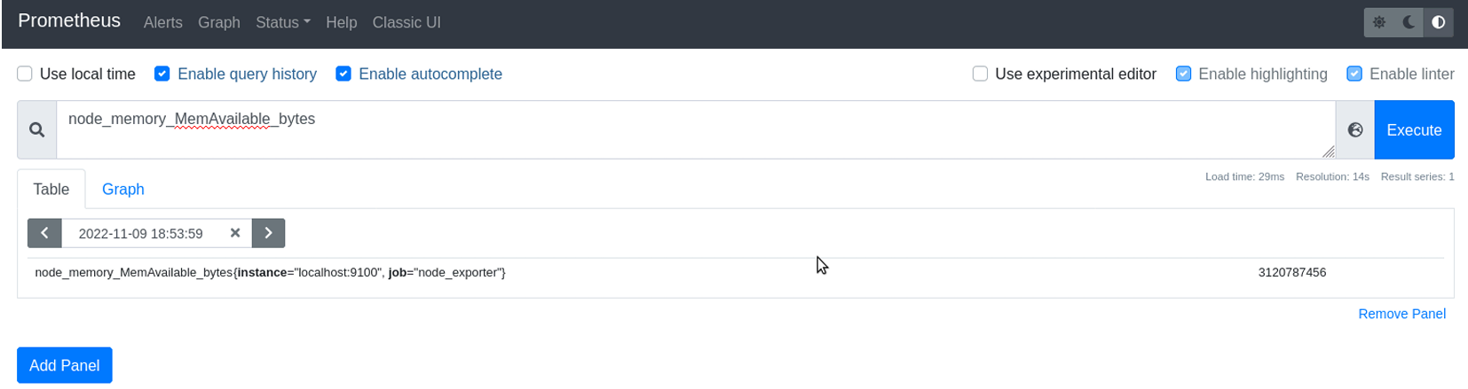

**Node memory available in MB**

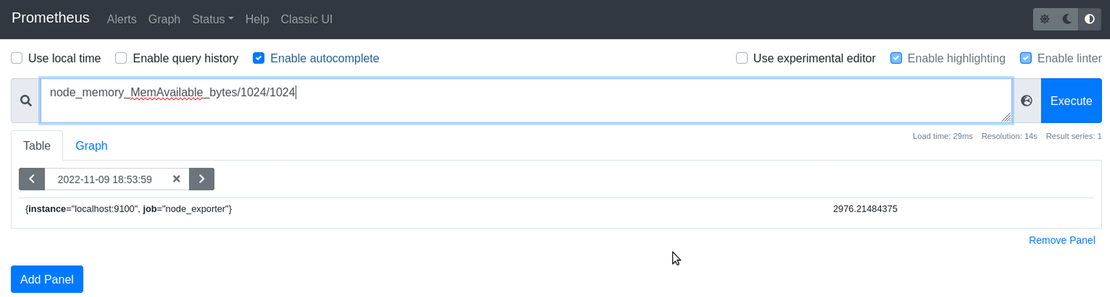

**Node memory available in MB for last 5min**

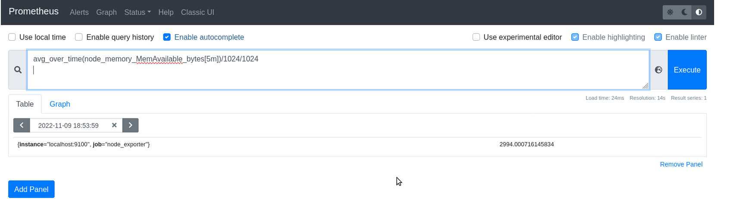

**Memory usage in percentage**

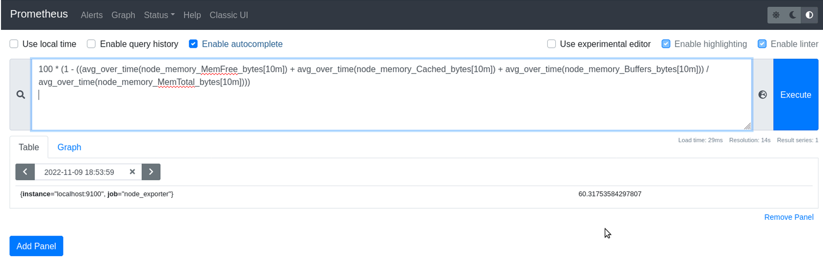

**Memory Available by Node**

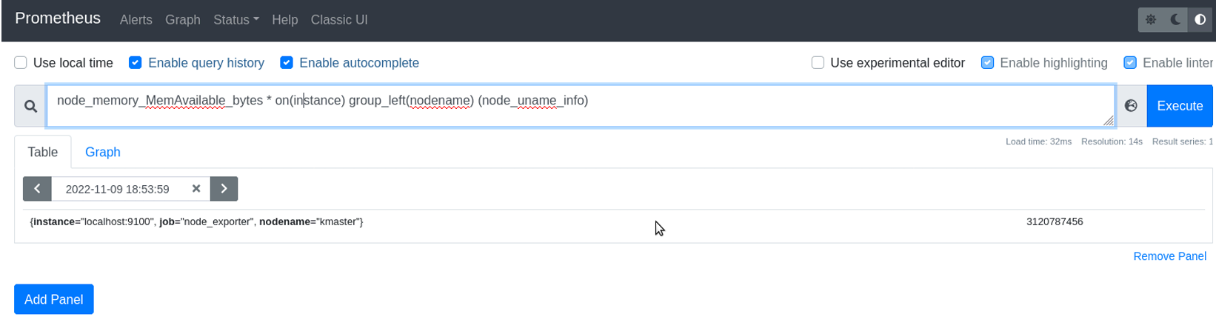

**Network monitoring.**

**Load average in percentage:**

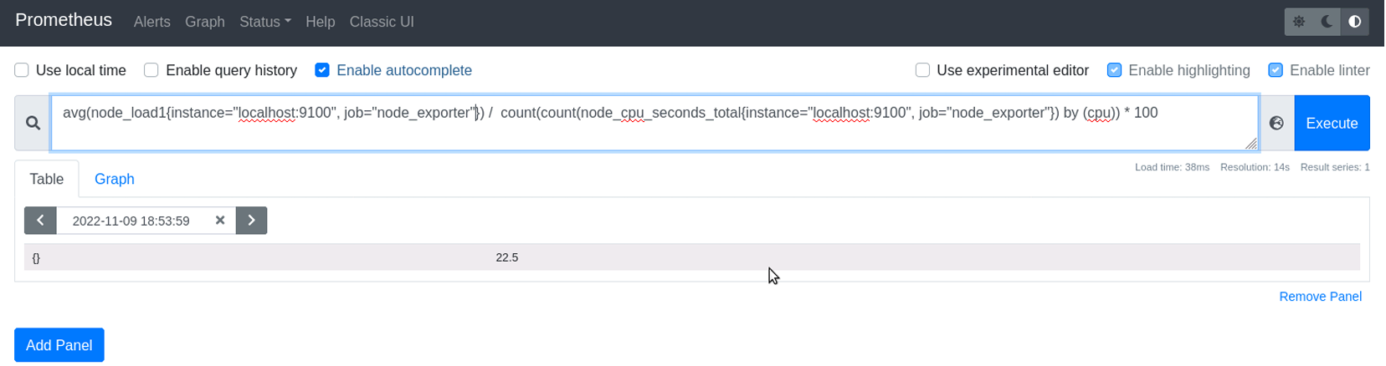

**Load Average per Instance:**

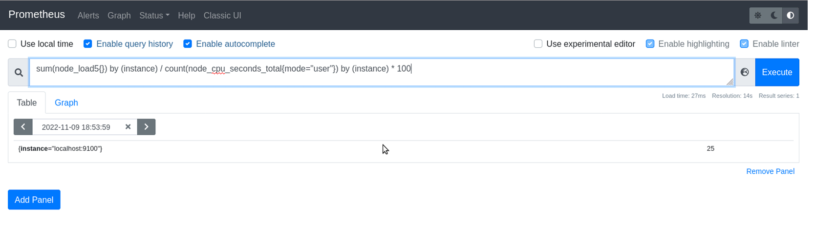

**Network inbound traffic per Node:**

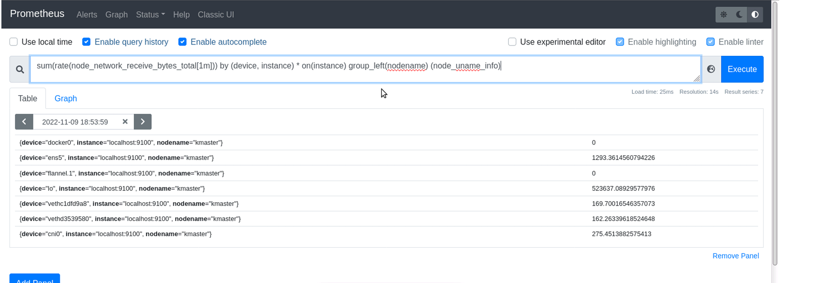

**Network outbound traffic per Node:**

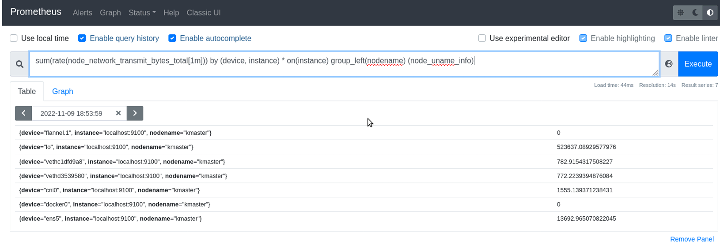

**Grafana screenshots:**

**Grafana home page:**

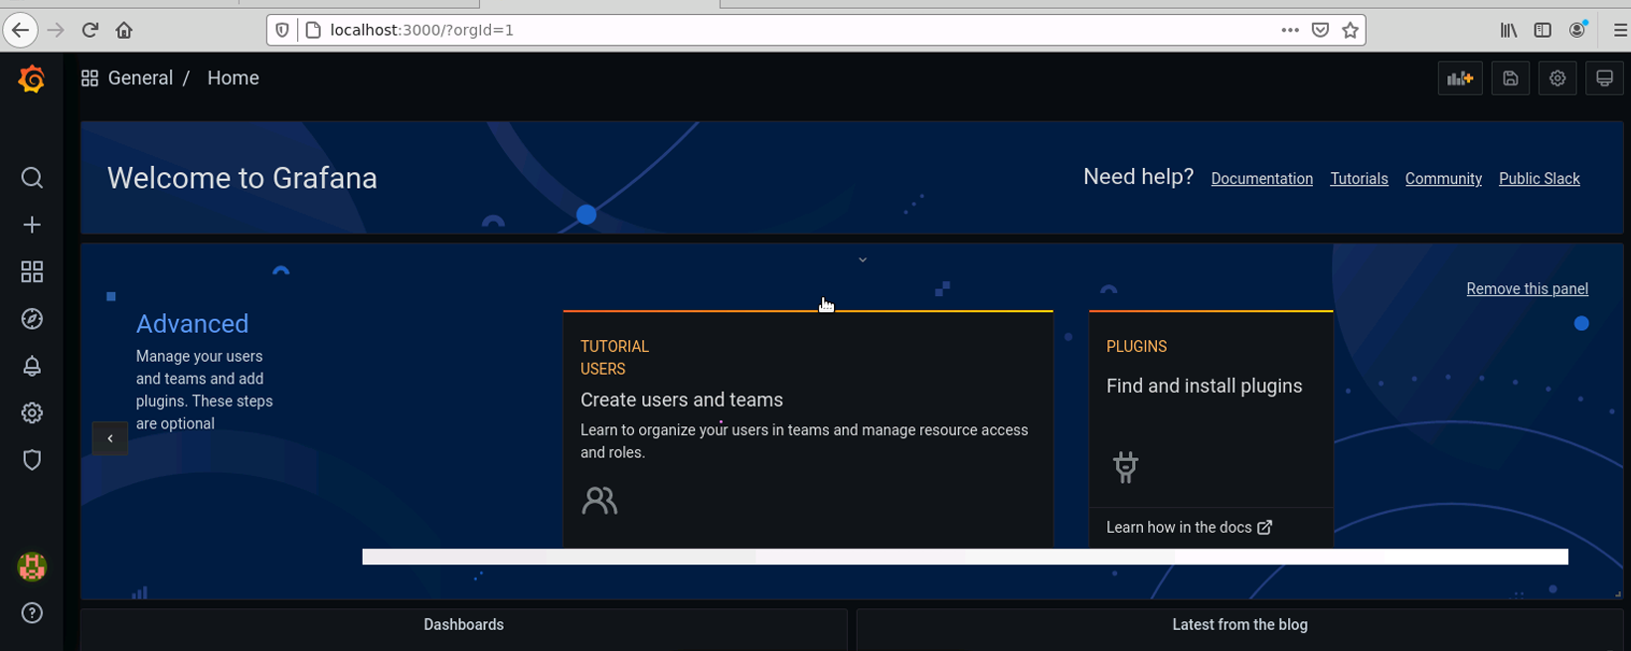

**Grafana data source selection(prometheus):**

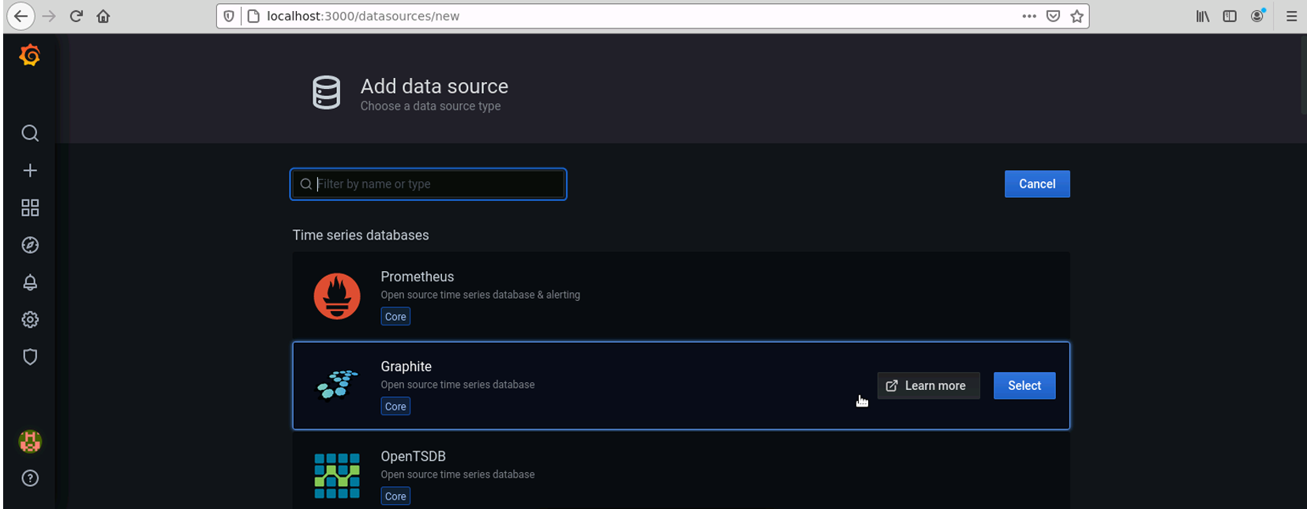

**Setting up the prometheus target:**

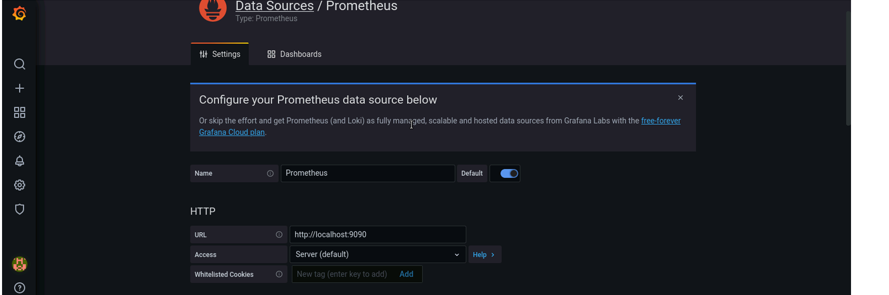

**Adding panel for prometheus:**

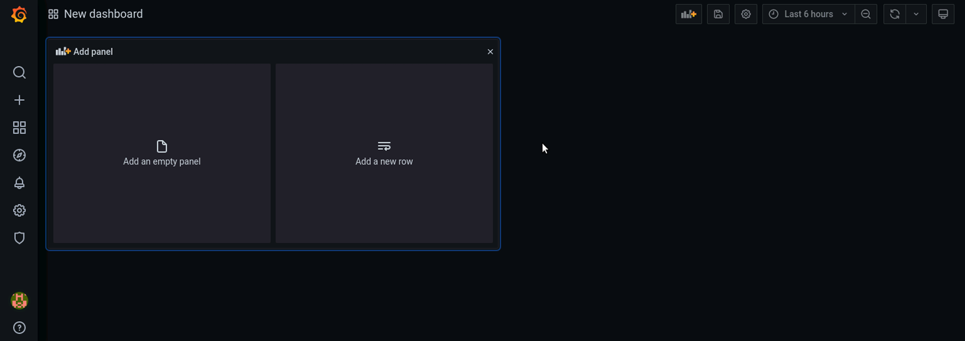

**Cpu monitoring 1**

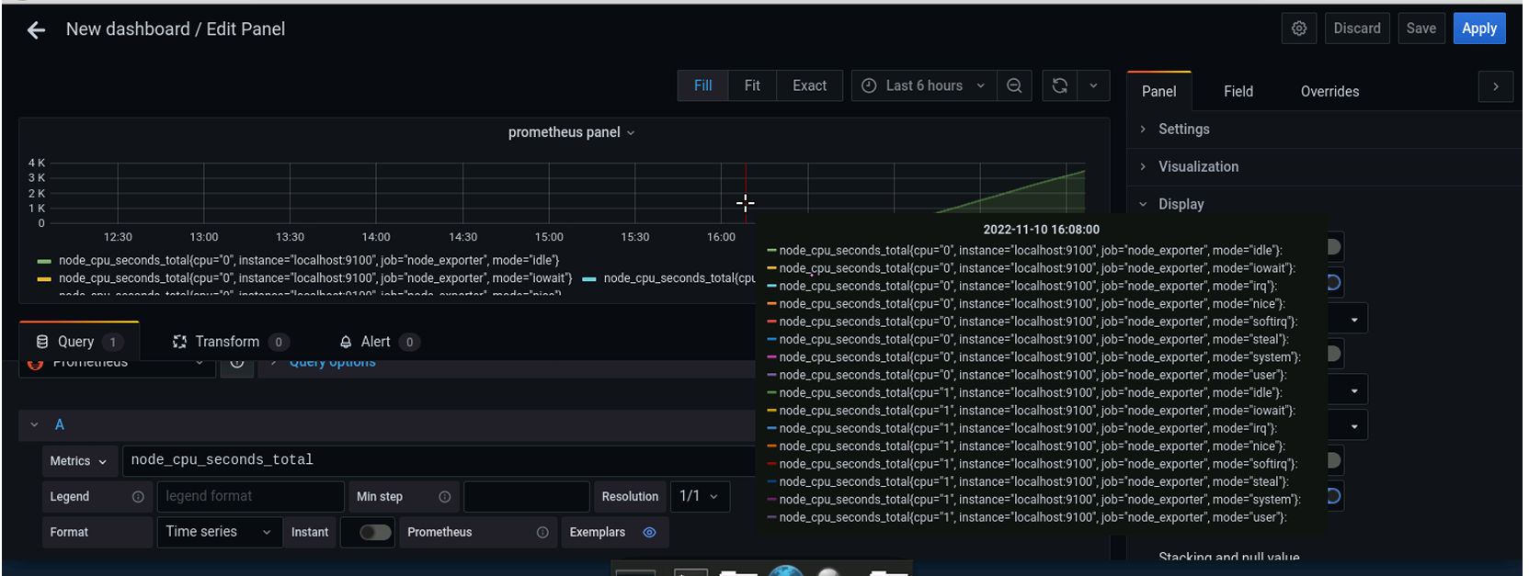

**Cpu monitoring 2**

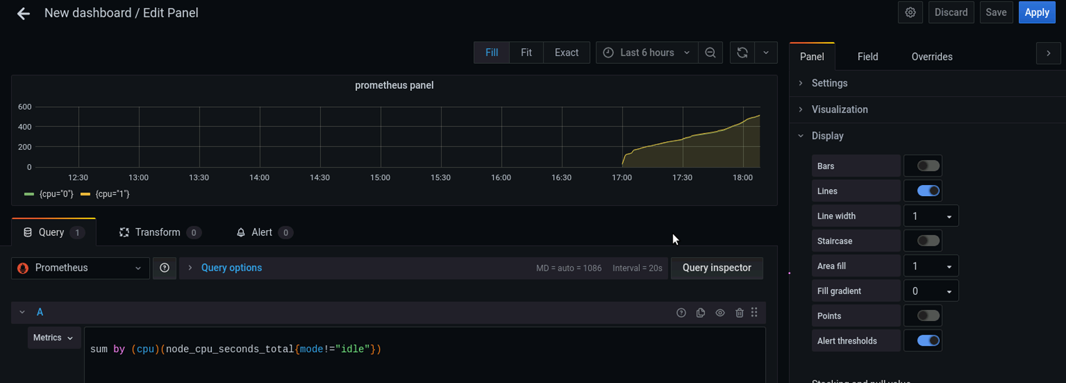

**Cpu monitoring 3**

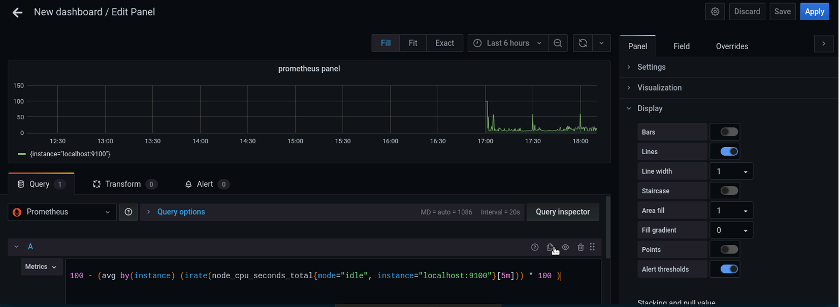

**Memory monitoring 1**

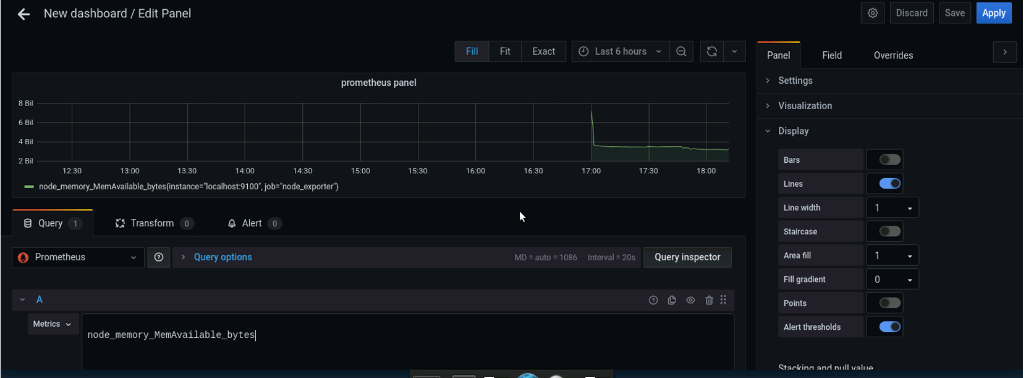

**Memory monitoring 2**

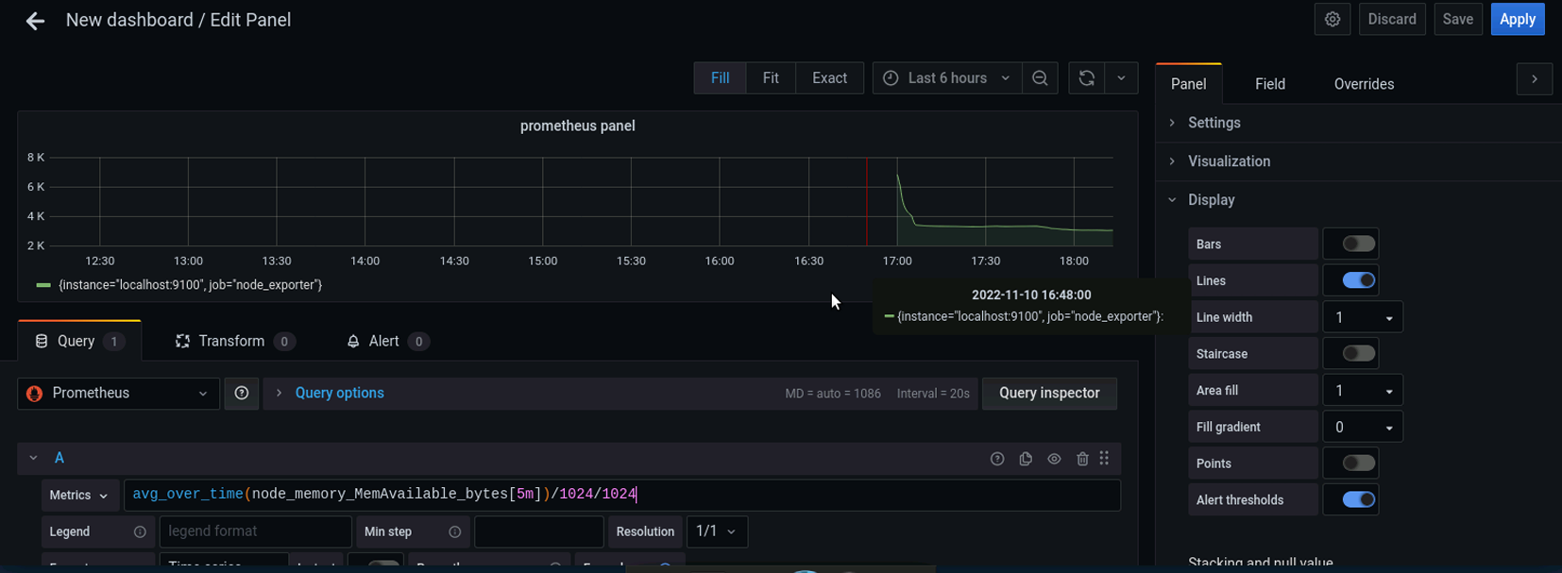

**Memory monitoring 3**

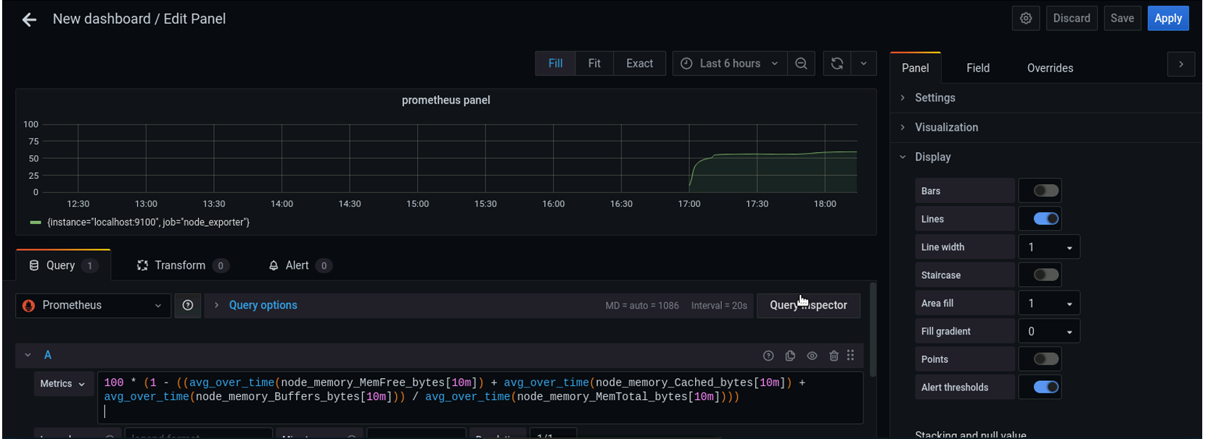

**Network load monitoring 1**

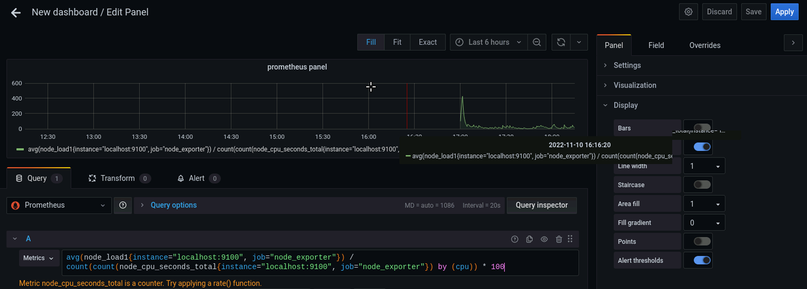

**Network load monitoring 2**

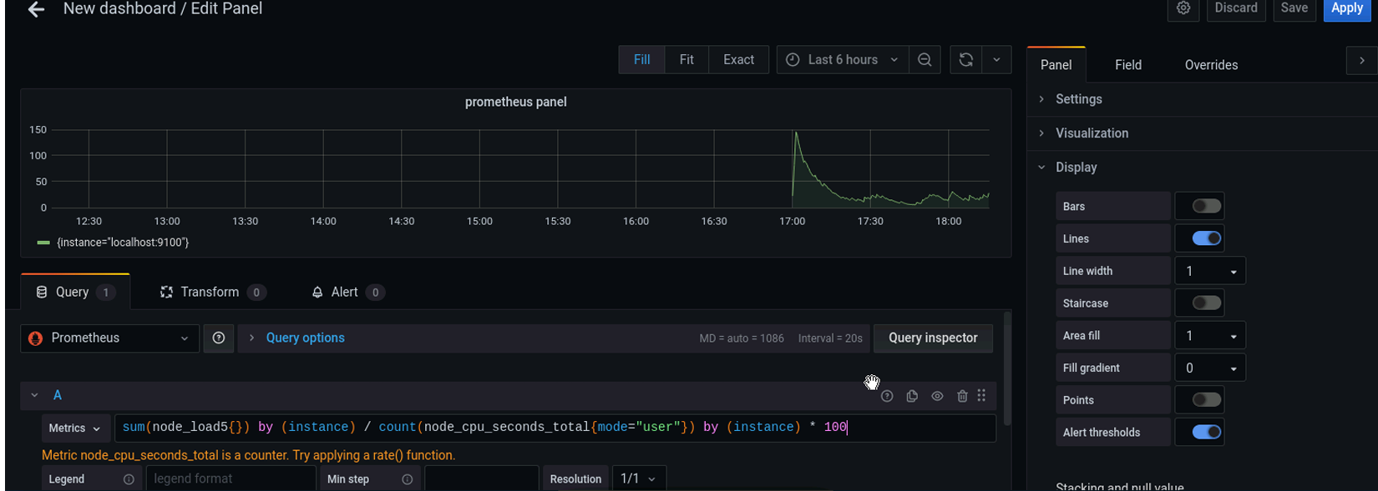

**Network monitoring 3**

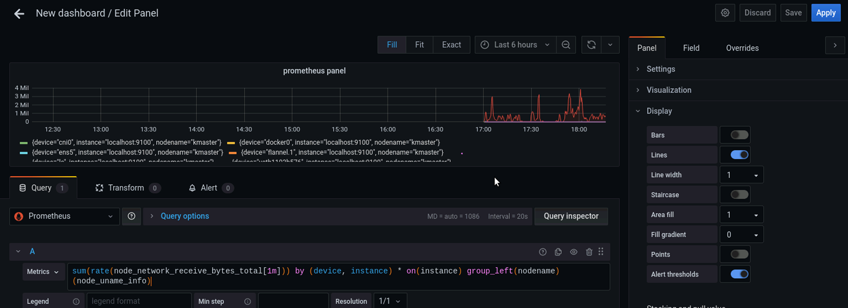

**Network load monitoring 4**

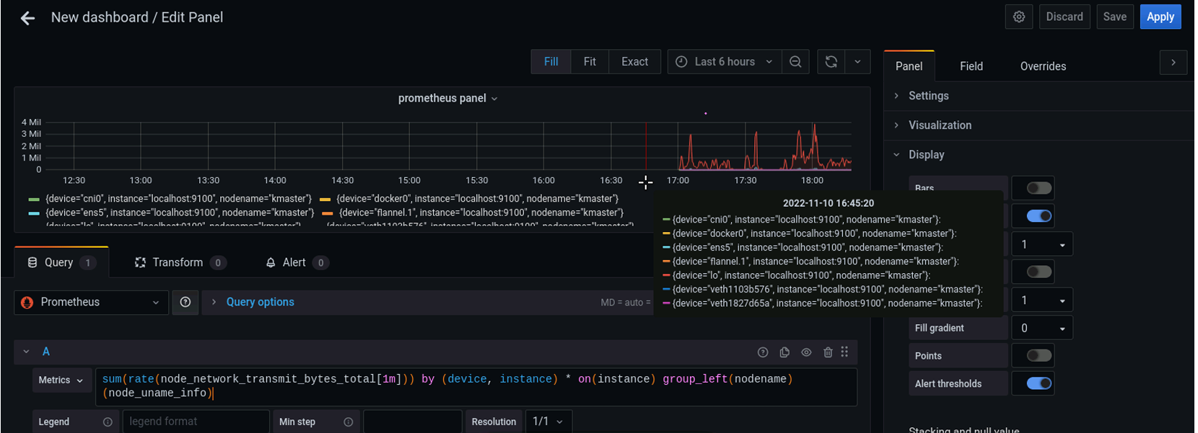

**Using different visualization graphs(Gauge)-cpu breakdown**

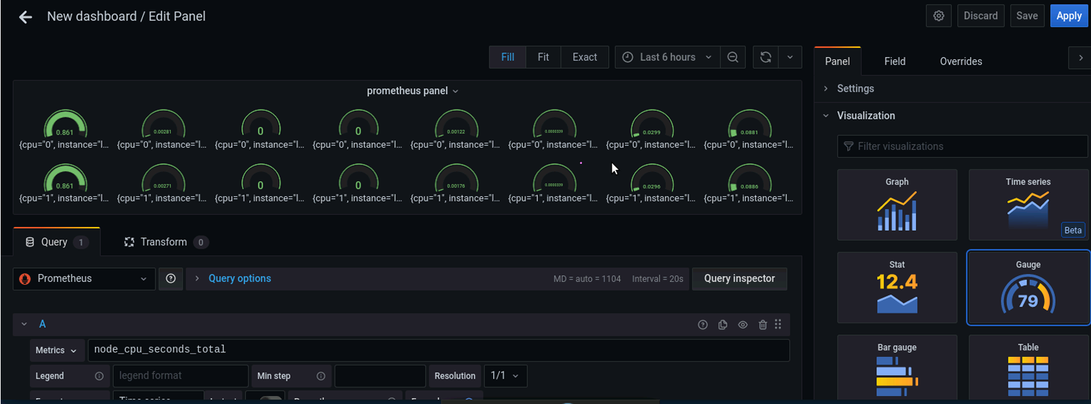

**Using different visualization graphs 2**

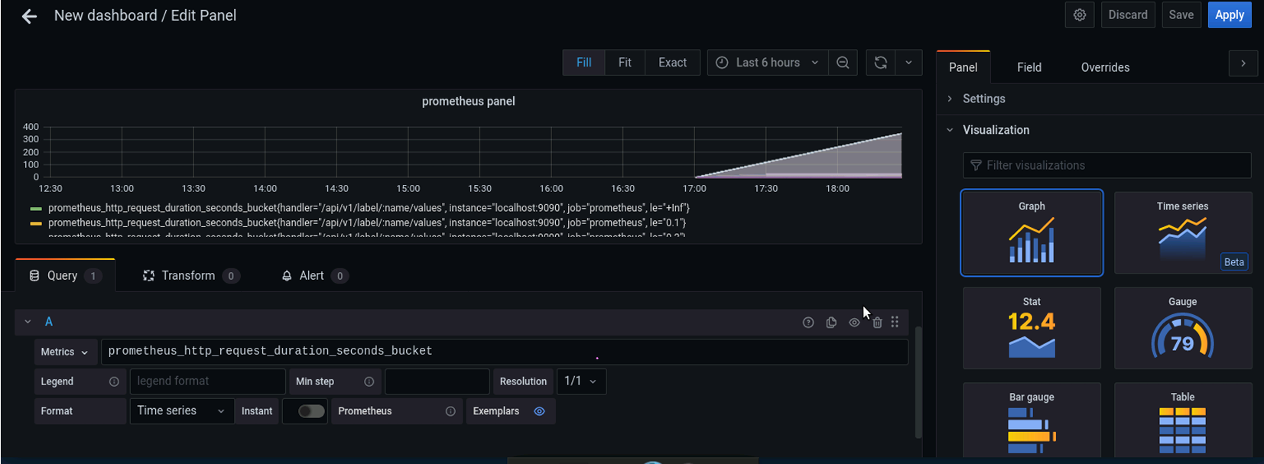

**Commands I used for Prometheus:**

